Potato Pizzas: Loaded Baked Potato Pizza
Description: Cheese Sauce, Sliced Baked Russet Potatoes, Green Onions, Bacon, Sour Cream, and Crushed Sour Cream and Onion, Potato Chips.
Servings: 8
Preparation Time: 20 minutes
Cooking Time: 20 minutes
Total Time: 40 minutes
Potato Type: Russet Potatoes, Potato Chips
Course: Main Entrée, Pizza, American

Ingredients
- 16-ounce Prepared Pizza Dough
- 10 fluid ounces Cheddar Cheese Sauce, prepared
- 4 ounces Cheddar Cheese, shredded
- 10 ounces Baked Russet Potatoes, sliced
- 6 ounces Applewood Smoked Bacon, cooked, chopped
- 5 ounces Sour Cream
- ½ cup Green Onions, sliced
- 2 tablespoons Unsalted Butter, melted
- 2 ounces Sour Cream and Onion Flavored Potato Chips, crushed

Preparation
- Preheat the oven to 425 F.
- Pull and stretch the dough so that a 16-inch round disc is formed. The dough should then be placed on a pizza peel sprinkled lightly with corn meal or flour to prevent sticking.
- Evenly spread a 10-ounce ladle of the prepared cheddar cheese sauce on the dough, this should be done by starting in the center of the disc and using the back of the ladle to evenly spread it outward. Make sure to leave about 1-inch un-sauced for the crust edge.
- Sprinkle the cheese evenly on top of the sauce. Followed by 10 ounces of the sliced baked potato.
- Top the pizza with 6 ounces of cooked and chopped applewood smoked bacon.
- Place the pizza in the oven on a pizza stone or on the back side of a sheet pan.
- Cook the pizza for 18-20 minutes, rotating it once halfway though to ensure even cooking.
- Remove the pizza from the oven and top it with the sour cream and green onions. Brush the crust with the melted butter. Sprinkle the crust with the crushed sour cream and onion flavored potato chips. Cut the pizza into 8 slices. Enjoy!

Notes
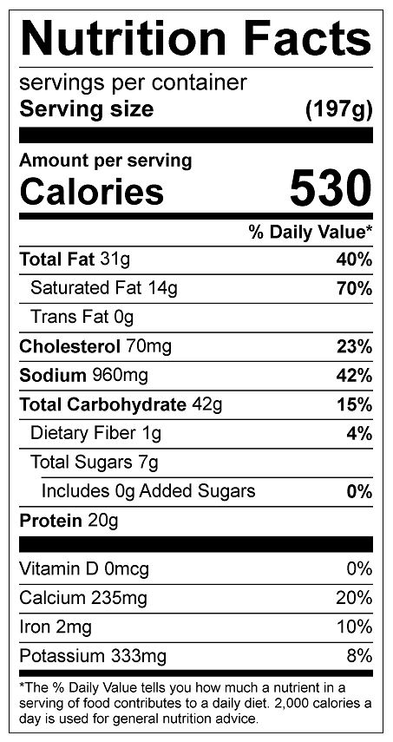
Vitamin C: 6.55 mg

