**Lemon and Dill Air Fryer Potato Wedges**



**Description:** Crispy Air Fryer Potato Wedges seasoned with zesty lemons and fragrant dill.

**Servings:** 4

**Preparation Time:** 7 minutes

**Cooking Time:** 25 minutes

**Total Time:** 32 minutes

**Potato Type:** Russet

**Course:** Side Dish, Snack

**Ingredients**

* As Needed Cooking Oil Spray
* 3 each (6 ounce) Russet Potato, washed and dried
* 1 tablespoon Olive Oil
* ½ teaspoon Fine Sea Salt
* ¼ teaspoon Freshly Ground Black Pepper
* 1 each Lemon, zested and juice removed
* ½ tablespoon Dill, fresh (If fresh isn’t available 1 teaspoon of dried dill can be substituted)

**Preparation**

1. Preheat the air fryer to 400 F
2. Slice the potatoes into wedges lengthwise, you should get 8 wedges per potato. To do this start by cutting the potato in half lengthwise, then cut each half in half, lengthwise, and lastly each quarter in half lengthwise. Place the potato wedges in a bowl and toss them with the olive oil.
3. Lightly Spray the air fryer basket with the cooking oil spray.
4. Place the potato wedges in the basket of the air fryer and cook the potatoes for 18 – 22 minutes or until they are golden brown and crispy on the outside but light and fluffy on the inside.
5. Gently remove the wedges from air fryer. Season them with the sea salt, black pepper, lemon zest, lemon juice, and dill.

**Notes**

* To zest a lemon, you will want a citrus zester, lightly run the zester on the outside of the citrus to remove just the yellow part (the white part of the lemon can be bitter. The zest can then be sprinkled over the potato wedges.
* A portion is 6 wedges
* Frozen potato wedges can also be substituted in this recipe for fresh potatoes. Cook the potatoes from frozen, reduce the cook time to 15 minutes in the air fryer if subbing frozen potato wedges or fry the potatoes to according to the instructions (nutritionals will vary with this method). Proceed with the recipe as directed after that.

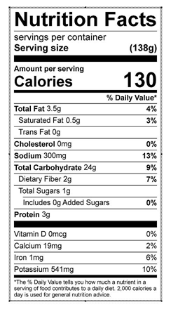

Vitamin C: 10.19 mg