**Kimchi Spiked Potato Salad**

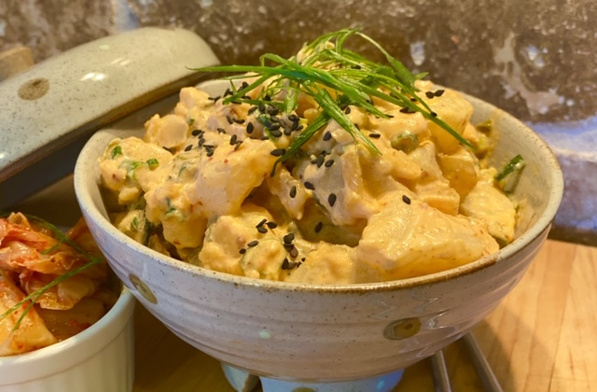

**Description:** A creamy potato salad flavored with ingredients from Korea.

**Servings:** 4

**Preparation Time:** 10 minutes

**Cooking Time:** 20 minutes

**Total Time:** 30 minutes

**Potato Type:** White

**Course: Side Dish**

**Ingredients**

* 1-pound White Potatoes, cut into 1-inch pieces
* ½ cup Mayonnaise
* ½ cup Prepared Kimchi, chopped fine
* ½ cup Green Onions (Scallions), roughly chopped
* 2 tablespoons Chili Garlic Sauce (Sriracha)
* As Needed Salt and Pepper

**Preparation**

1. Rinse and scrub the potatoes and then cut them into 1-inch sized pieces.
2. Place the potatoes into a pot and cover the potatoes with water and place over high heat. Bring the potatoes to a boil, reduce the heat to medium and cook the potatoes for 15 minutes or until they are soft but not falling apart. Drain the potatoes and allow them the cool in the fridge for 5-10 minutes.
3. In a large bowl combine the mayonnaise with the kimchi, green onions, and chili sauce.
4. Stir in the cooled potatoes and adjust the seasoning with the salt and pepper.
5. Serve right away or, place in the refrigerator overnight, this will allow the flavors to meld and the potato salad to be even better.

**Notes**

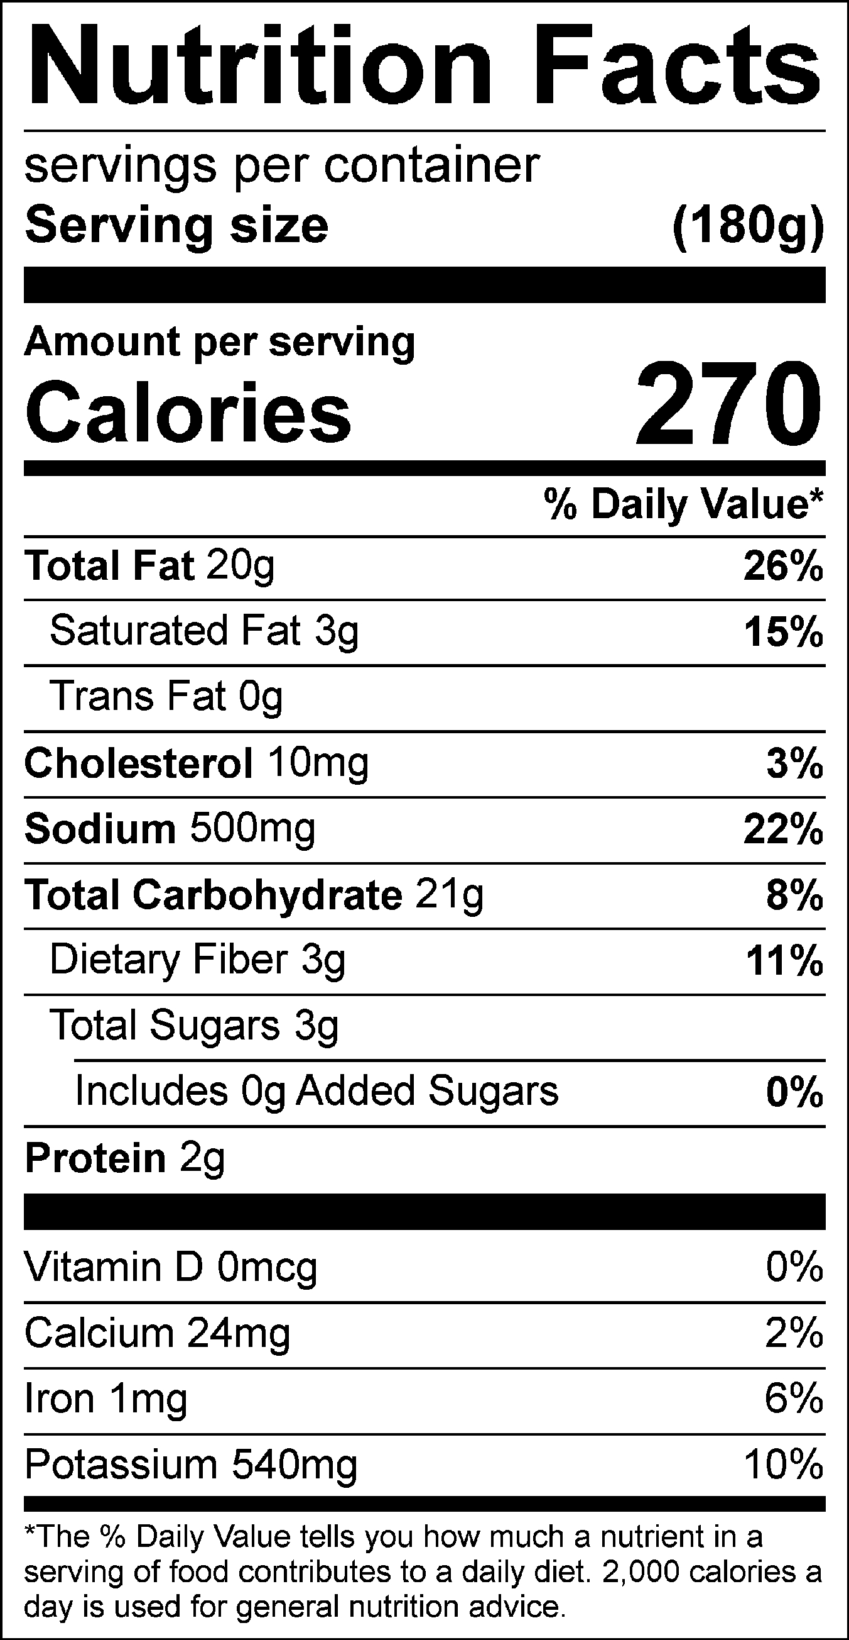

Vitamin C: 14.55 mg