**Hoisin BBQ Tots with Glazed Smoked Pork Belly**

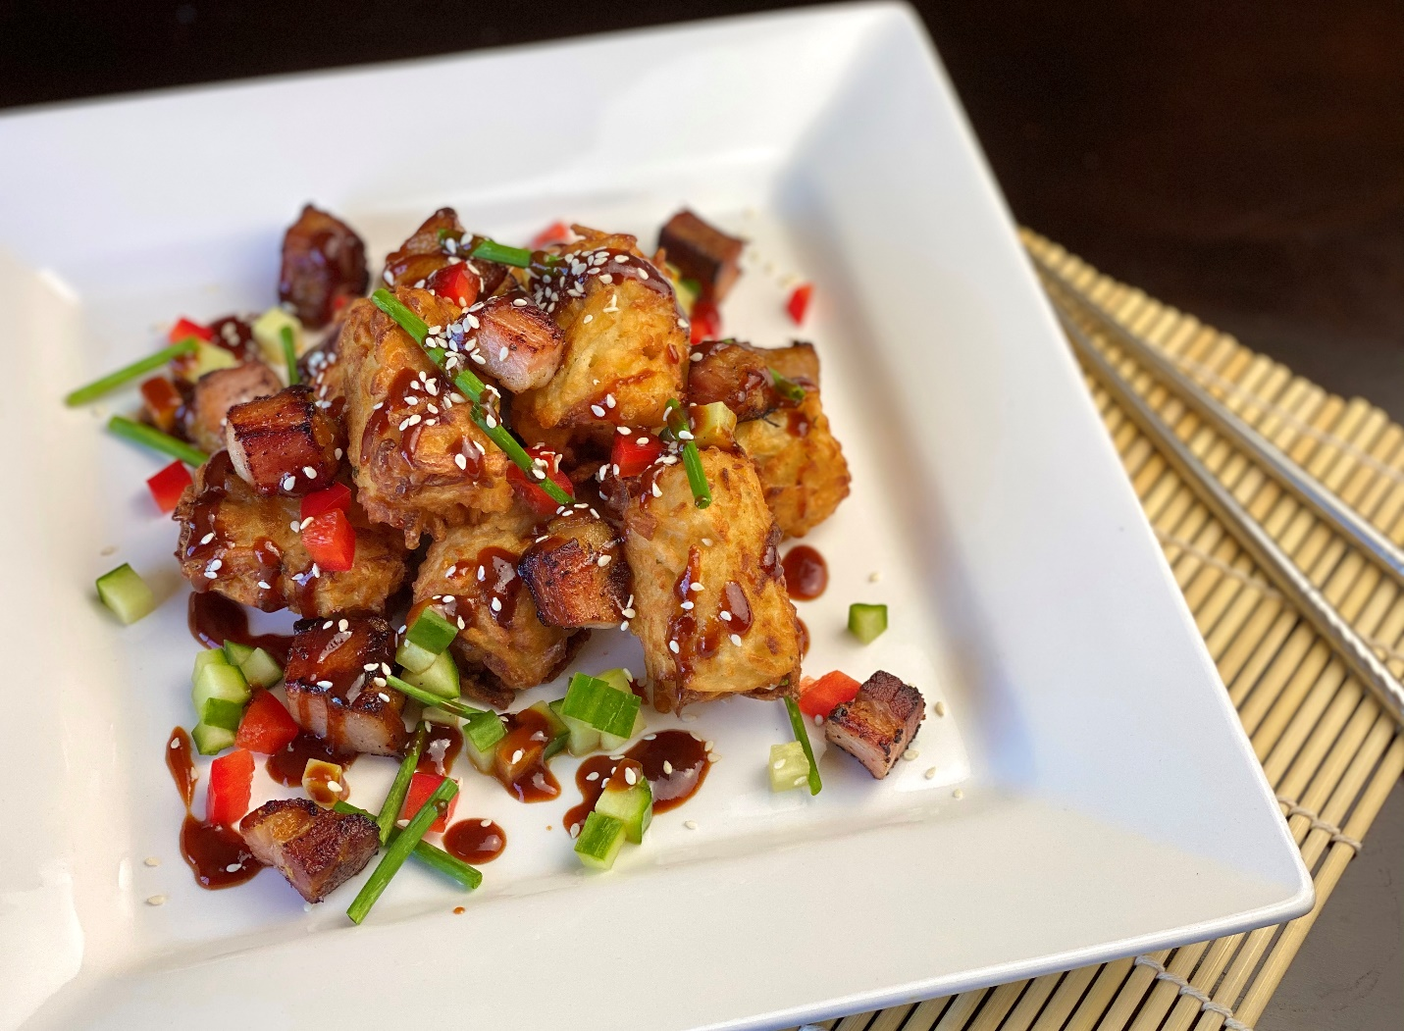

**Description:** Crispy seasoned tots with tender glazed smoked pork belly and cool garden-fresh veggies.

**Servings:** 24

**Preparation Time:** 40 minutes

**Cooking Time:** 20 minutes

**Total Time:** 60 minutes

**Potato Type:** Dehydrated Potato Shreds

**Course:** Side Dish, Main Entrée, Shared Plate, Asian

**Ingredients**

* 4 cups Dehydrated Potato Shreds
* 6 cups Boiling Water
* ¾ cup All-Purpose flour
* 1 teaspoon Garlic Powder
* 1/2 teaspoon Onion Powder
* 1 tablespoon Kosher Salt
* ½ tablespoon Freshly Ground Black Pepper
* 8 quarts Vegetable Oil for frying
* 1-1/2 pounds Smoked Slab Bacon, cut into ½ inch cubes
* ½ cup Hoisin
* 1 cup BBQ Sauce
* 1 cup English Cucumbers, diced ¼ inch
* 1 cup Red Bell Pepper, diced ¼ inch
* ½ cup Sesame Seeds
* ½ cup Chives

**Preparation**

1. Place the dehydrated potatoes in a large bowl and cover with the boiling water. Allow the potatoes to sit for 10-15 minutes.
2. Drain the potatoes very well and place them in a piece of cheesecloth or a kitchen towel to help eliminate any excess moisture.
3. Place the potatoes into a food processor. Add the flour, garlic powder, onion powder, salt, and pepper. Pulse a few times to combine but do not puree mix.
4. Transfer the mixture to a bowl and using a small portion scoop or two teaspoons, make small cylinders with the potato mixture. Arrange the tots on a baking sheet lined with a silpat or parchment paper.
5. Place the tots in the freezer and allow them to freeze overnight.
6. In a small sauté pan heat the bacon until crispy on the outside yet still tender on the inside, set aside.
7. Heat the oil to 365 °F, fry the tots for 7-8 minutes or until golden brown. Drain the tots on a paper towel to remove any excess oil.
8. Combine the hoisin and BBQ sauce. Set aside
9. To plate arrange the tots on a serving platter and top with the bacon.
10. Drizzle the tots and bacon with the hoisin BBQ sauce.
11. Top the dish with the bell peppers, cucumber, sesame seeds, and chives.

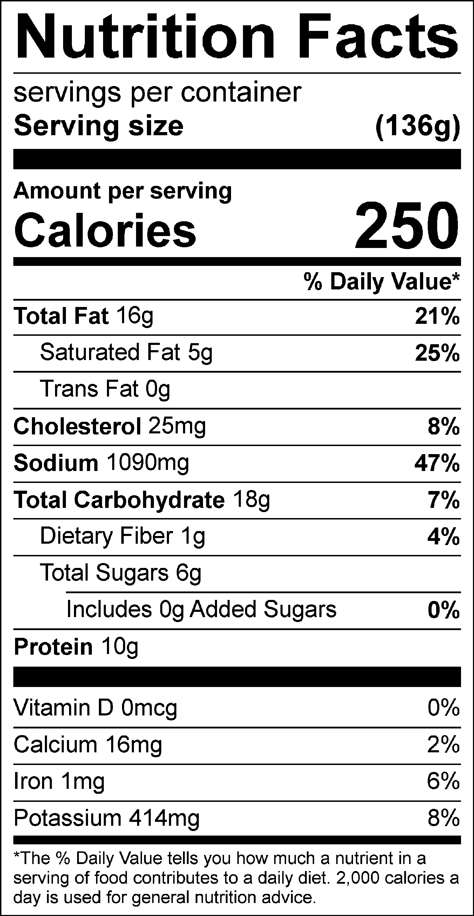

Vitamin C: 8.70mg