**Hash Brown Crusted Mac and Cheese Gratin**

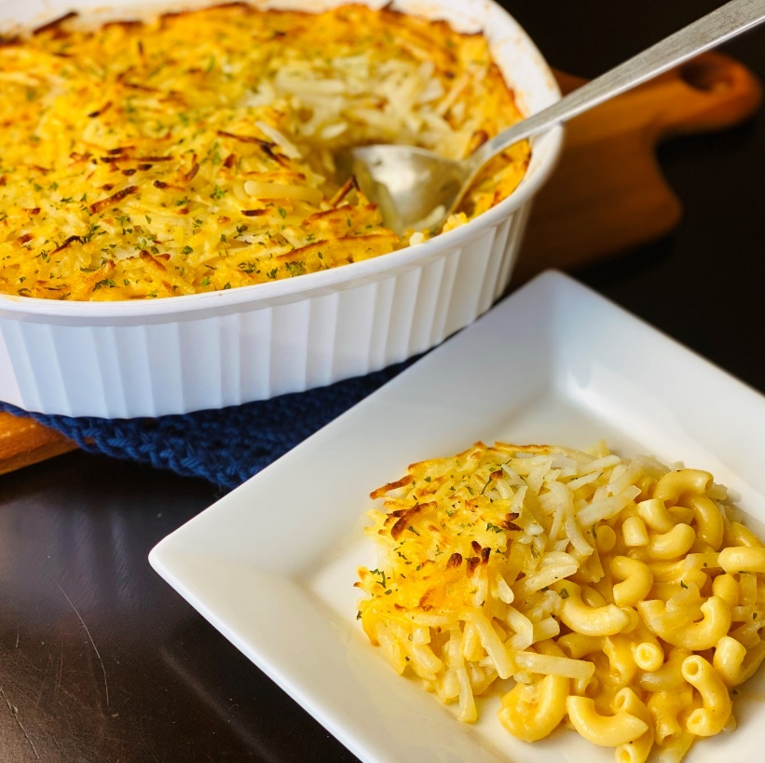

**Description:** Crispy hash browns on top bubbling, creamy, mac and cheese for the ultimate side dish.

**Servings:** 24

**Preparation Time:** 20 minutes

**Cooking Time:** 45 minutes

**Total Time:** 65 minutes

**Potato Type:** Dehydrated Potato Shreds

**Course:** Side Dish, Main Entrée

**Ingredients**

* 6 cups Elbow Macaroni
* 1 gallon Boiling Water
* 6 cups Half and Half
* 4 cups Grated Cheddar Cheese
* 1 tablespoon Kosher Salt
* ½ tablespoon Freshly Ground Black Pepper
* 4 cups Dehydrated Potato Shreds
* 6 cups Boiling Water
* 2 ounces Ranch Seasoning Mix
* ½ cup Unsalted Butter, melted
* ½ cup Chopped Parsley (optional)

**Preparation**

1. In a large pot, cook the elbow macaroni in the boiling water for 8-10 minutes or until tender. Drain the pasta and set aside.
2. In a large saucepan, bring the half & half to a simmer, stir in the grated cheddar and remove from the heat. Combine the cheese sauce with the pasta and adjust the seasoning with the salt and pepper.
3. Transfer the mac and cheese to a baking dish.
4. Meanwhile, place the dehydrated potato shreds into a large bowl and cover them with the hot water. Allow the potatoes to sit for 8-10 minutes or until they are rehydrated.
5. Drain the potatoes very well and combine them with the ranch seasoning and butter. Evenly spread the hash browns on top of the mac and cheese layer.
6. Place into a 375-degree oven for 30 until the hash brown topping is golden and crispy.
7. Garnish with parsley if desired. Enjoy!

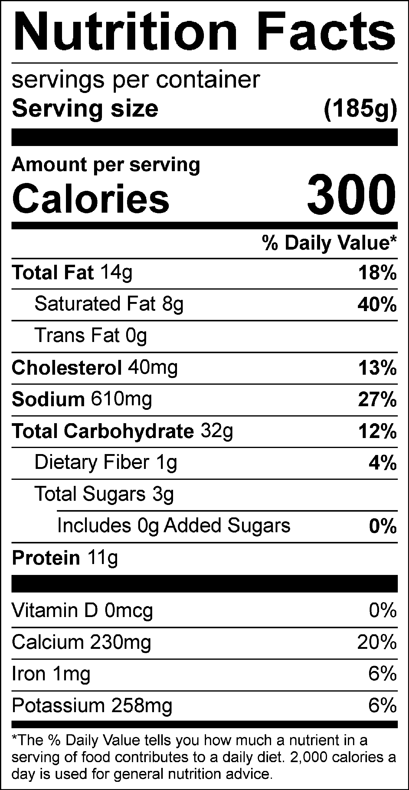

Vitamin C: 0mg