**Green Chili Enchilada Potatoes**



Description: Potato wedges are smothered in savory green chili, topped with cheese, and baked in the oven before getting topped with fresh tomatoes and green onions.

Servings: 4

Preparation Time: 10 minutes

Cooking Time: 20 minutes

Total Time: 30 minutes

Course: Lunch, Dinner, Entree

Ingredients:

1-pound Yellow Potatoes, cut into wedges (8 per potato)

2 tablespoons Olive Oil

As Needed Salt and Pepper

3 cups Prepared Green Chili Sauce (Salsa Verde can be subbed)

¾ cup Shredded Mild Cheddar Cheese

¼ cup Roma Tomatoes, diced

¼ cup Green Onions, diced

¼ cup Sour Cream (Optional)

Directions:

1. Rinse and scrub the potatoes, then cut them into wedges. You should have 8 wedges per potato.
2. Toss the potatoes in the olive oil, and season with salt and pepper to taste.
3. Bake for 20-25 minutes until the potatoes are golden brown on the outside and tender on the outside.
4. While the potatoes are in the oven, gently heat the green chili in a sauté pan, when the potatoes are done arrange the potatoes in the pan with the green chili. Top the potatoes and green chili with the shredded cheddar cheese, and place in the oven for 3-5 minutes until the cheese is melted.
5. Remove from the oven and top with the tomatoes, green onions, and sour cream.

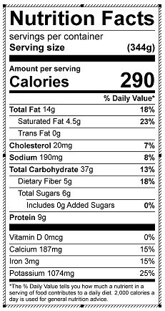

Vitamin C: 144 mg