**Ginger Scallion Potato Latkes with Miso Butter**

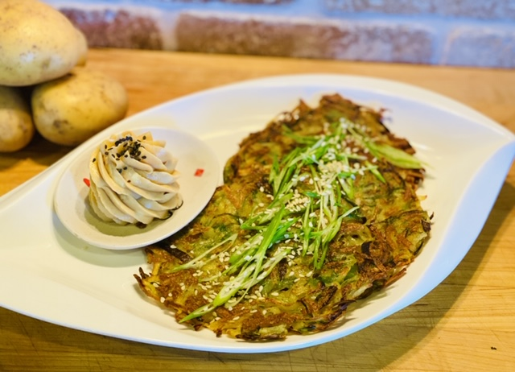

Description: Crispy potato pancakes flavored with ginger and spring onions then served with a creamy miso seasoned butter.

Servings: 4

Preparation Time: 15 minutes

Cooking Time: 10 minutes

Total Time: 25 minutes

Course: Sharable Appetizer, Side Dish

Ingredients:

1-pound Yellow Potatoes, grated on the large side of a box grater

½ cup Green Onions (Scallions), sliced thin

2 teaspoons Ground Ginger

As Needed Salt and Pepper

2 tablespoons Vegetable Oil

½ cup Unsalted Butter, softened

1 tablespoon Shiro Miso

Preparation:

1. Rinse, scrub and grate the potatoes on the large size grater side of a box grater.
2. Add the sliced green onions, ginger, and season with salt and pepper to taste.
3. In a non-stick pan heat the vegetable oil over medium heat. Form thin patties of the potato pancakes using your hands. Gently place the potato pancakes into the preheated pan with the oil (you may have to work in batches depending on the size of your pan). Cook the potatoes for about 3-5 minutes on each side until they are golden brown. Remove them from the pan and keep warm in a low oven.
4. To make the miso butter, combine the unsalted butter with the miso in a small bowl until well mixed. Serve the butter with the crispy potato pancakes.

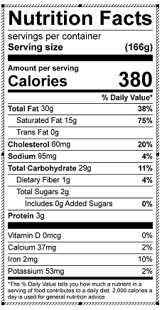

Vitamin C: 20 mg