Foil Wrapped Potato Meals: Fiesta Potatoes with Chicken
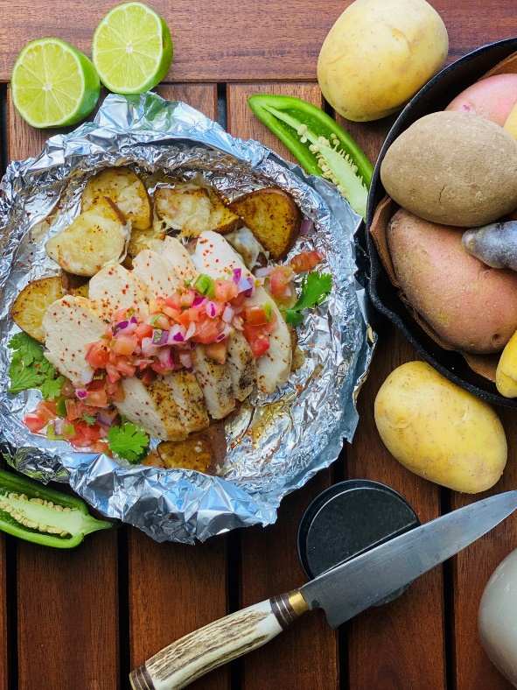
Description: Chili and lime seasoned chicken and potatoes with melted pepper jack cheese and salsa.
Servings: 4
Preparation Time: 10 minutes
Cooking Time: 35 minutes
Total Time: 45 minutes
Potato Type: Russet Potatoes
Course: Main Entrée

Ingredients
- 1-1/2 pounds (roughly 5 medium) Russet Potatoes, washed and cut into ½ moons
- 4 each (6 ounces) *1.5 pounds Chicken Breast, Boneless/Skinless
- 1 tablespoon Olive Oil
- 2-1/2 tablespoons Chili Lime Seasoning
- 8 ounces Shredded Pepper Jack Cheese
- ½ cup Fresh Salsa (Prepared)

Preparation
- Preheat the oven to 400 °F, this can also be done on the grill, simply preheat to 400 °F. If cooking outdoors without a thermometer and over an open flame (cook time may vary slightly).
  - Recommend an instant read meat thermometer to check the internal temperature of the chicken.
- Place the potatoes onto a large square of aluminum foil.
- Drizzle the chicken and the potatoes with the olive oil and season with the chili lime seasoning.
- Wrap the foil around the food by creating an envelope style fold over the top and rolling the edges up, this will make it easier to check the temperature of the meat.
- Place the foil pouch into the oven or over the campfire on a grate. Allow the packages to cook for about 30 minutes or until the potatoes are tender and the juice from the chicken run clear.
  - It’s important to rotate the foil package around the heat from time to time to prevent scorching.
- Remove the chicken from the foil package and allow it to rest slightly while completing the dish.
- To finish the dish, top the potatoes with the shredded pepper jack cheese and place back in the oven or on the fire to allow the cheese to melt.
- Slice the chicken breast and place it on top of the potatoes.
- Top the chicken breast and potatoes with prepared salsa and enjoy.
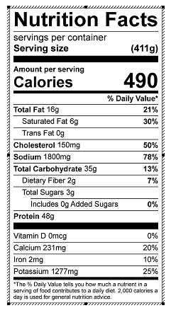
Vitamin C: 48 mg

