**Elote Style Air Fryer Potato Wedges**

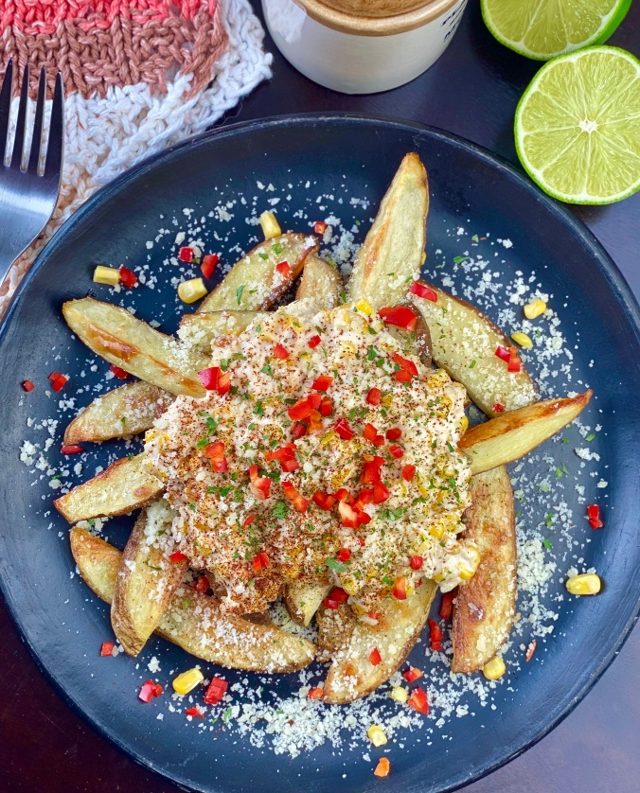

**Description:** Crispy air fryer potato wedges topped with creamy and cheesy sweet corn.

**Servings:** 4

**Preparation Time:** 7 minutes

**Cooking Time:** 25 minutes

**Total Time:** 32 minutes

**Potato Type:** Russet

**Course:** Lunch entrée, dinner entree, shared appetizer

**Ingredients**

* As Needed Cooking Oil Spray
* 3 each (6 ounce) Russet Potato, washed and dried
* 1 tablespoon Olive Oil
* ½ teaspoon Fine Sea Salt
* ¼ teaspoon Freshly Ground Black Pepper
* 1 cup Frozen Sweet Corn
* ¼ cup Mayonnaise
* ¼ cup Sour Cream
* ¼ cup Cotija Cheese (Grated Parmesan can be subbed)
* ½ tablespoon Smoked Paprika

**Preparation**

1. Preheat the air fryer to 400 °F
2. Slice the potatoes into wedges lengthwise, you should get 8 wedges per potato. To do this start by cutting the potato in half lengthwise, then cut each half in half, lengthwise, and lastly each quarter in half lengthwise. Place the potato wedges in a bowl and toss them with the olive oil.
3. Lightly Spray the air fryer basket with the cooking oil spray.
4. Remove the potato slices from the water and drain well before laying them on some paper towel to dry.
5. Place the potato wedges in the basket of the air fryer and cook the potatoes for 18 – 22 minutes or until they are golden brown and crispy on the outside but light and fluffy on the inside.
6. While the potatoes are cooking, make the corn. Begin by heating the corn over medium high heat when the corn is hot remove from the heat. Stir in the mayonnaise, sour cream and cheese. Keep warm while the potatoes cook.
7. Gently remove the wedges from air fryer. Top the potato wedges with the sautéed corn mixture and sprinkle with the smoked paprika.

**Notes**

* Chili Lime Seasoning can be subbed for the paprika if desired.
* A portion is 6 wedges
* Frozen potato wedges can also be substituted in this recipe for fresh potatoes. Cook the potatoes from frozen, reduce the cook time to 15 minutes in the air fryer if subbing frozen potato wedges or fry the potatoes to according to the instructions (nutritionals will vary with this method). Proceed with the recipe as directed after that.

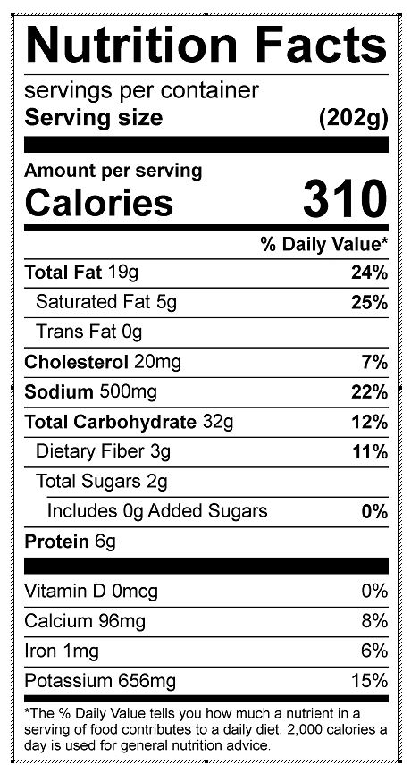

Vitamin C: 9.58 mg