**Crispy Air Fryer Breakfast Potatoes**

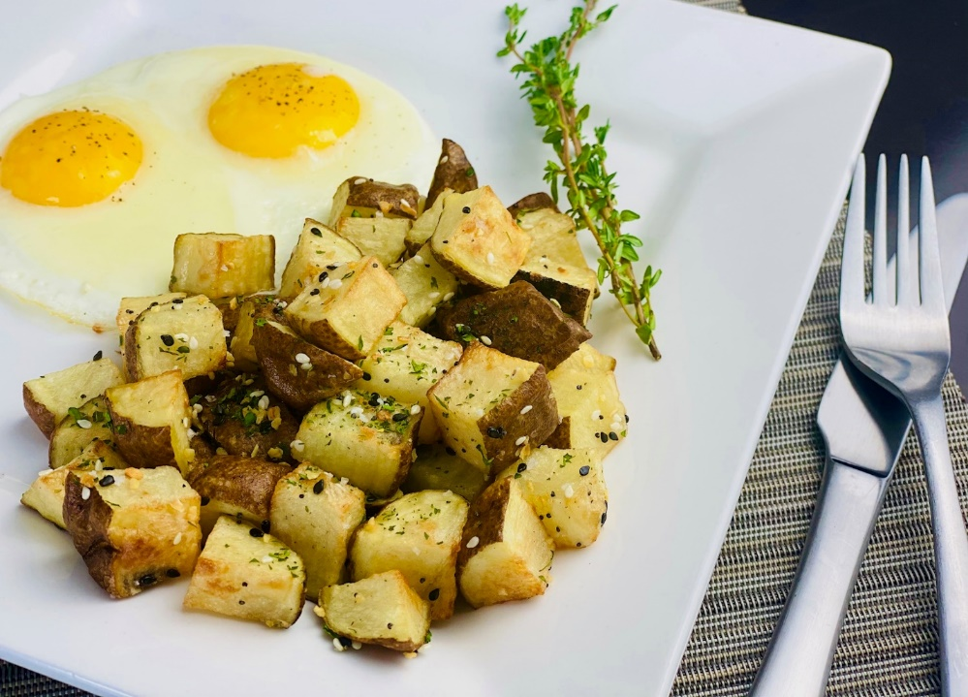

**Description:** Delicious breakfast potatoes cooked in an air fryer make for the perfect side to any breakfast.

**Servings:** 4

**Preparation Time:** 10 minutes

**Cooking Time:** 20 minutes

**Total Time:** 30 minutes

**Potato Type:** Russet

**Course:** Breakfast, Brunch, Side Dish

**Ingredients**

* As Needed Cooking Oil Spray
* 2 each (6 ounce) Russet Potato, washed and dried
* 2 tablespoons Olive Oil
* ½ teaspoon Fine Sea Salt
* ¼ teaspoon Freshly Ground Black Pepper
* 1 tablespoon Everything Bagel Seasoning
* ¾ tablespoon Chopped Parsley, fresh (If fresh isn’t available 1/4 tablespoon of dried parsley can be substituted)

**Preparation**

1. Preheat the air fryer to 390 °F
2. Slice the potatoes into 1-inch cubes.
3. Place the potatoes into a bowl and add the olive oil, toss to coat evenly and season with salt and pepper.
4. Lightly Spray the air fryer basket with the cooking oil spray.
5. Place the potatoes in the basket of the air fryer and cook the potatoes for 20 minutes or until they are golden brown and crispy on the outside but light and fluffy on the inside.
6. Remove the potatoes from the air fryer and season them with the everything bagel seasoning and parsley. Serve and enjoy.

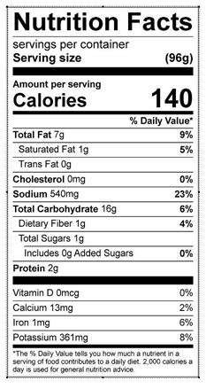

Vitamin C: 5.8 mg