**Potato Pizzas: Chorizo Tot Mexicali Pizza (Vegan)**

**Description:** Salsa Verde, roasted corn, tomatoes, black beans, chorizo spiced tots, cilantro and avocado “crema”

**Servings:** 8

**Preparation Time:** 20 minutes

**Cooking Time:** 40 minutes

**Total Time:** 60 minutes

**Potato Type:** Frozen Tater Drums/Barrels

**Course:** Main Entrée

**Ingredients**

* 10 ounces [Potato Chorizo](https://www.potatogoodness.com/recipes/potato-chorizo/)
* 1 tablespoon Extra Virgin Olive Oil
* ¾ cup Sweet Corn, cut off the cob
* 16-ounce Prepared Pizza Dough
* 10 fluid ounces Prepared Salsa Verde
* ¾ cup Black Beans, canned, drained, rinsed
* ½ cup Diced Roma Tomatoes
* ¼ cup Cilantro, roughly chopped

Avocado “Crema”

* ½ each Avocado
* 2 tablespoons Lime Juice
* 1 tablespoon Chopped Fresh Jalapeno
* As Needed Cold Water
* 1 teaspoon Kosher Salt

**Preparation**

1. Preheat the oven to 425 °F.
2. Prepare the potato chorizo according to the recipe. <https://www.potatogoodness.com/recipes/potato-chorizo/>
3. In a skillet over high heat, heat the olive oil until it just starts to smoke, immediately add the corn, toss the corn in hot pan until the corn is slightly charred and golden. Remove from the heat and allow to cool until ready to use.
4. Pull and stretch the dough so that a 16-inch round disc is formed. The dough should then be placed on a pizza peel sprinkled lightly with corn meal or flour to prevent sticking.
5. Evenly spread a 10-ounce ladle of the prepared salsa verde on the dough, this should be done by starting in the center of the disc and using the back of the ladle to evenly spread it outward. Make sure to leave about 1-inch un-sauced for the crust edge.
6. Arrange the potato chorizo along with the charred corn, and black beans on the salsa verde.
7. Place the pizza in the oven on a pizza stone or on the back side of a sheet pan.
8. Cook the pizza for 18-20 minutes, rotating it once halfway through to ensure even cooking.
9. To prepare the avocado crema, place the avocado, lime juice, and jalapeno in a high-speed blender, puree until smooth, adjust the consistency with a little water until a sauce is formed. Adjust the seasoning with the salt and set aside until ready for use.
10. Remove the pizza from the oven and top it with the diced tomatoes, and cilantro. Drizzle the pizza with the avocado “crema”. Cut the pizza into 8 slices and enjoy!

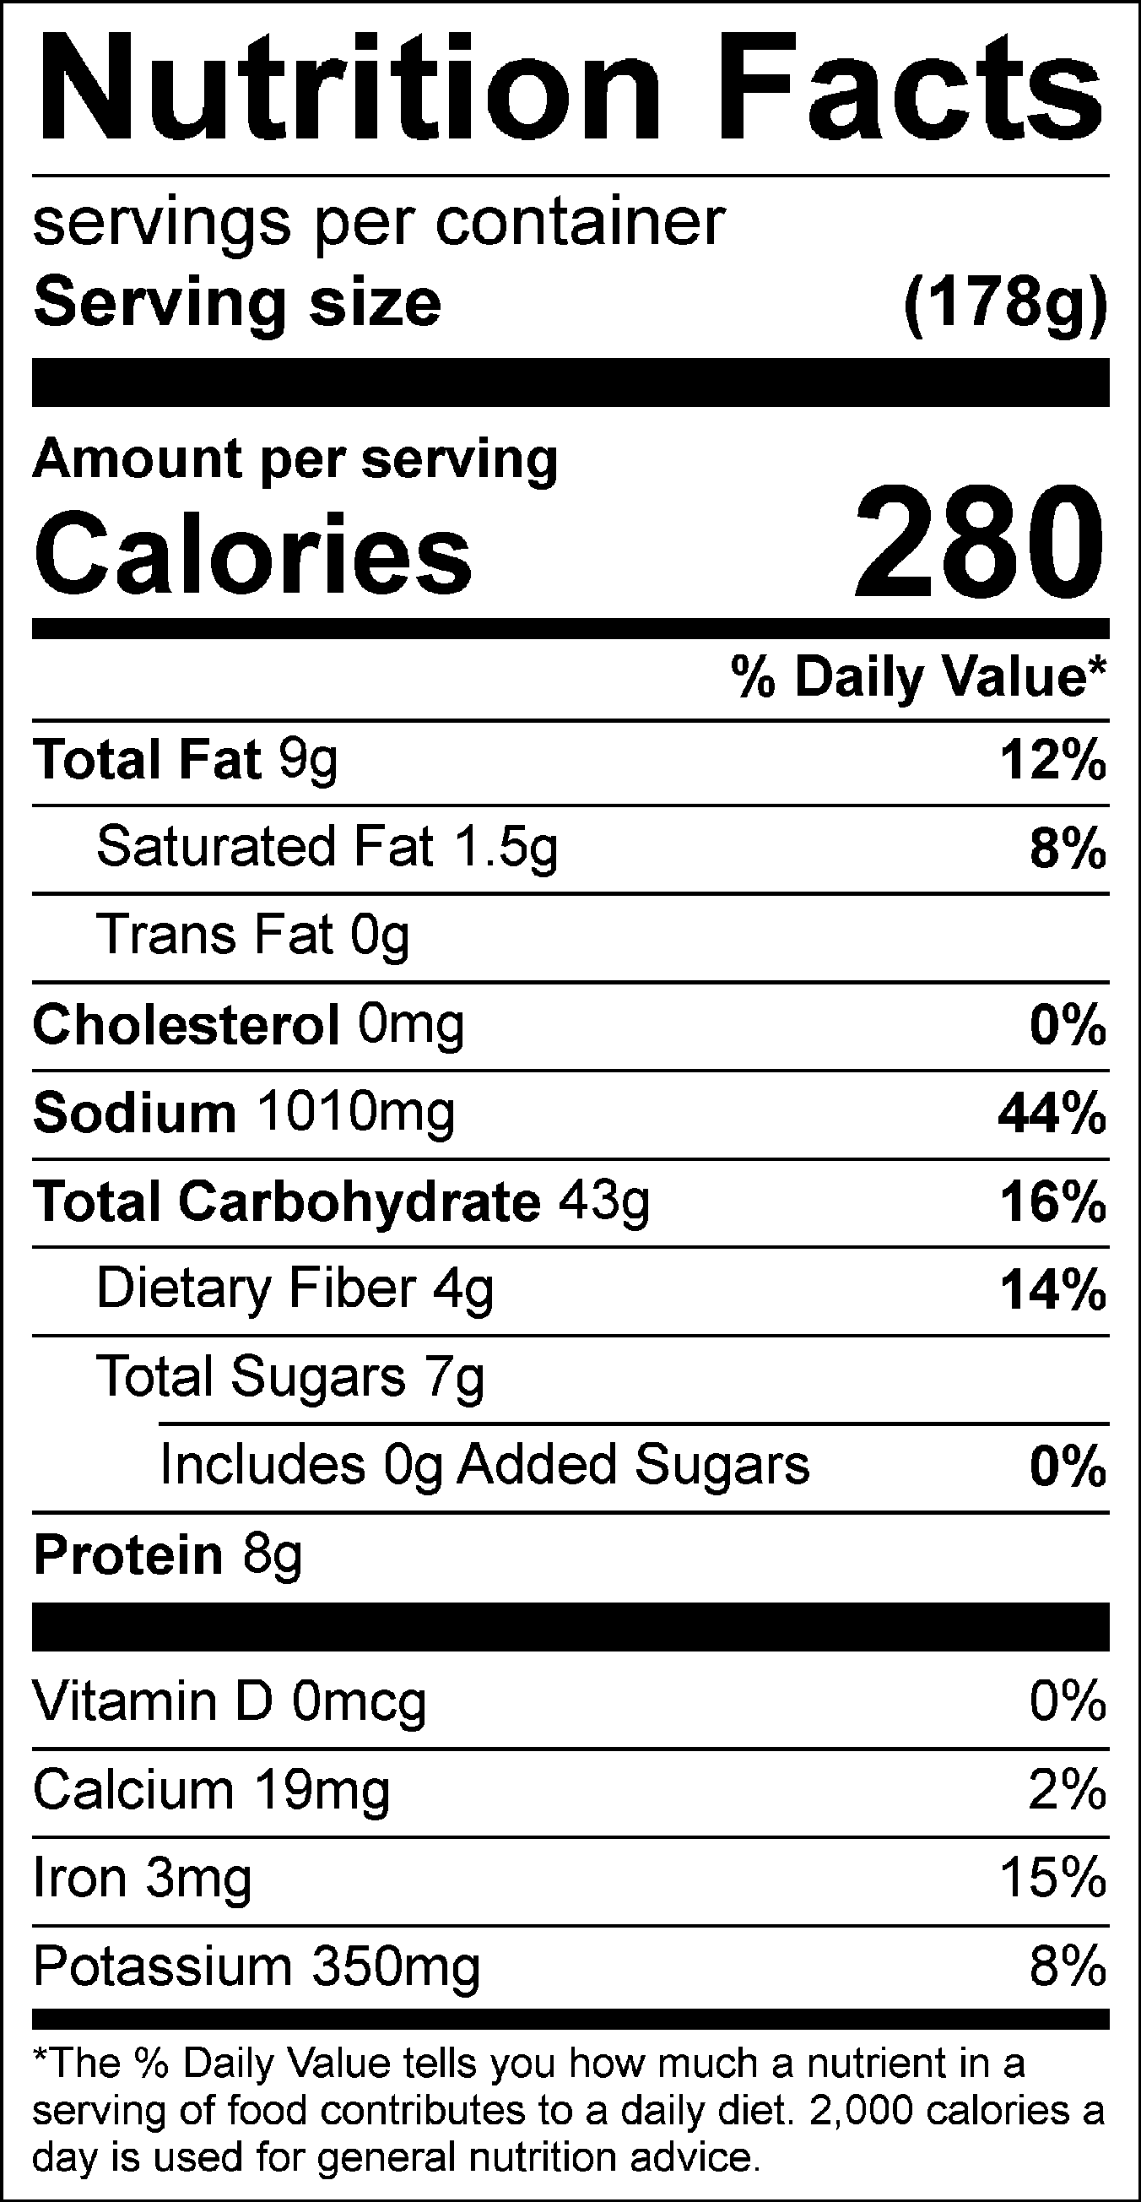

Vitamin C: 13.04mg