**Cheesy Alfredo Style Potatoes**

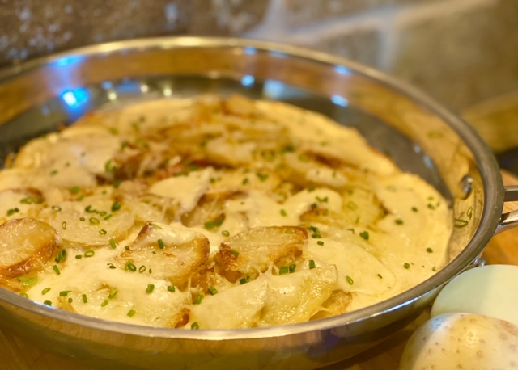

**Description:** The flavors of roasted garlic, parmesan, and cream, envelop crispy potatoes for a rich and satisfying dish.

**Servings:** 4

**Preparation Time:** 5 minutes

**Cooking Time:** 25 minutes

**Total Time:** 30 minutes

**Potato Type:** White

**Course:** Lunch, Dinner, Entree

**Ingredients**

1-pound White Potatoes, Sliced ¼ inch thick

2 tablespoons Extra Virgin Olive Oil

As Needed Salt and Pepper

1-1/2 cups Prepared Alfredo Sauce

¼ cup Shredded Parmesan Cheese

2 tablespoons Chopped Chives (Optional)

**Preparation**

1. Preheat the oven to 450 °F.
2. Rinse and scrub the potatoes and cut them into ¼ inch slices.
3. Arrange the slices in an oven safe sauté pan and bake them for 25 minutes until the top of the potatoes are golden brown.
4. Remove the pan from the oven and Spoon the prepared alfredo sauce on the potatoes. Sprinkle the top with parmesan and return to the oven for 3-5 minutes.
5. Remove from the oven and serve immediately.

**Notes**

* Nutritional information does not include optional chopped chives.

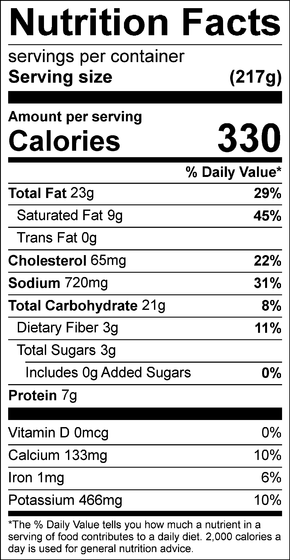

Vitamin C: 10.32 mg