**Buffalo Potato Bites**



**Servings:** 4

**Preparation Time:** 10 minutes

**Cooking Time:** 20 minutes

**Total Time:** 30 minutes

**Potato Type:** Red

**Ingredients:**

* 1-pound Red Potatoes, cut into wedges (about 4-6 wedges per potato)
* 3 tablespoons Olive Oil
* As Needed Salt and Pepper
* ½ cup Buffalo Sauce
* ½ cup Prepared Blue Cheese Dressing (Ranch can also be subbed)
* ½ cup Celery, cut into thin strips
* ½ cup Carrots, cut into thin strips
* 1/3 cup Green Onions, chopped (Optional)

**Directions:**

1. Preheat the oven to 450 F
2. Wash, scrub and cut the potatoes into wedges.
3. Place the potato wedges into a large bowl. Add the olive oil and season with salt and pepper. Toss to combine, and arrange the potatoes on an aluminum foil lined baking sheet.
4. Place the potatoes in the oven and bake them for 20-25 minutes or until they are golden brown on the outside and light and fluffy on the inside. Remove from the oven and keep warm until ready to plate.
5. To plate arrange the roasted potato wedges on a serving platter. Drizzle the potatoes with the buffalo sauce and the blue cheese. Top the potatoes with the carrots, celery, and green onions.

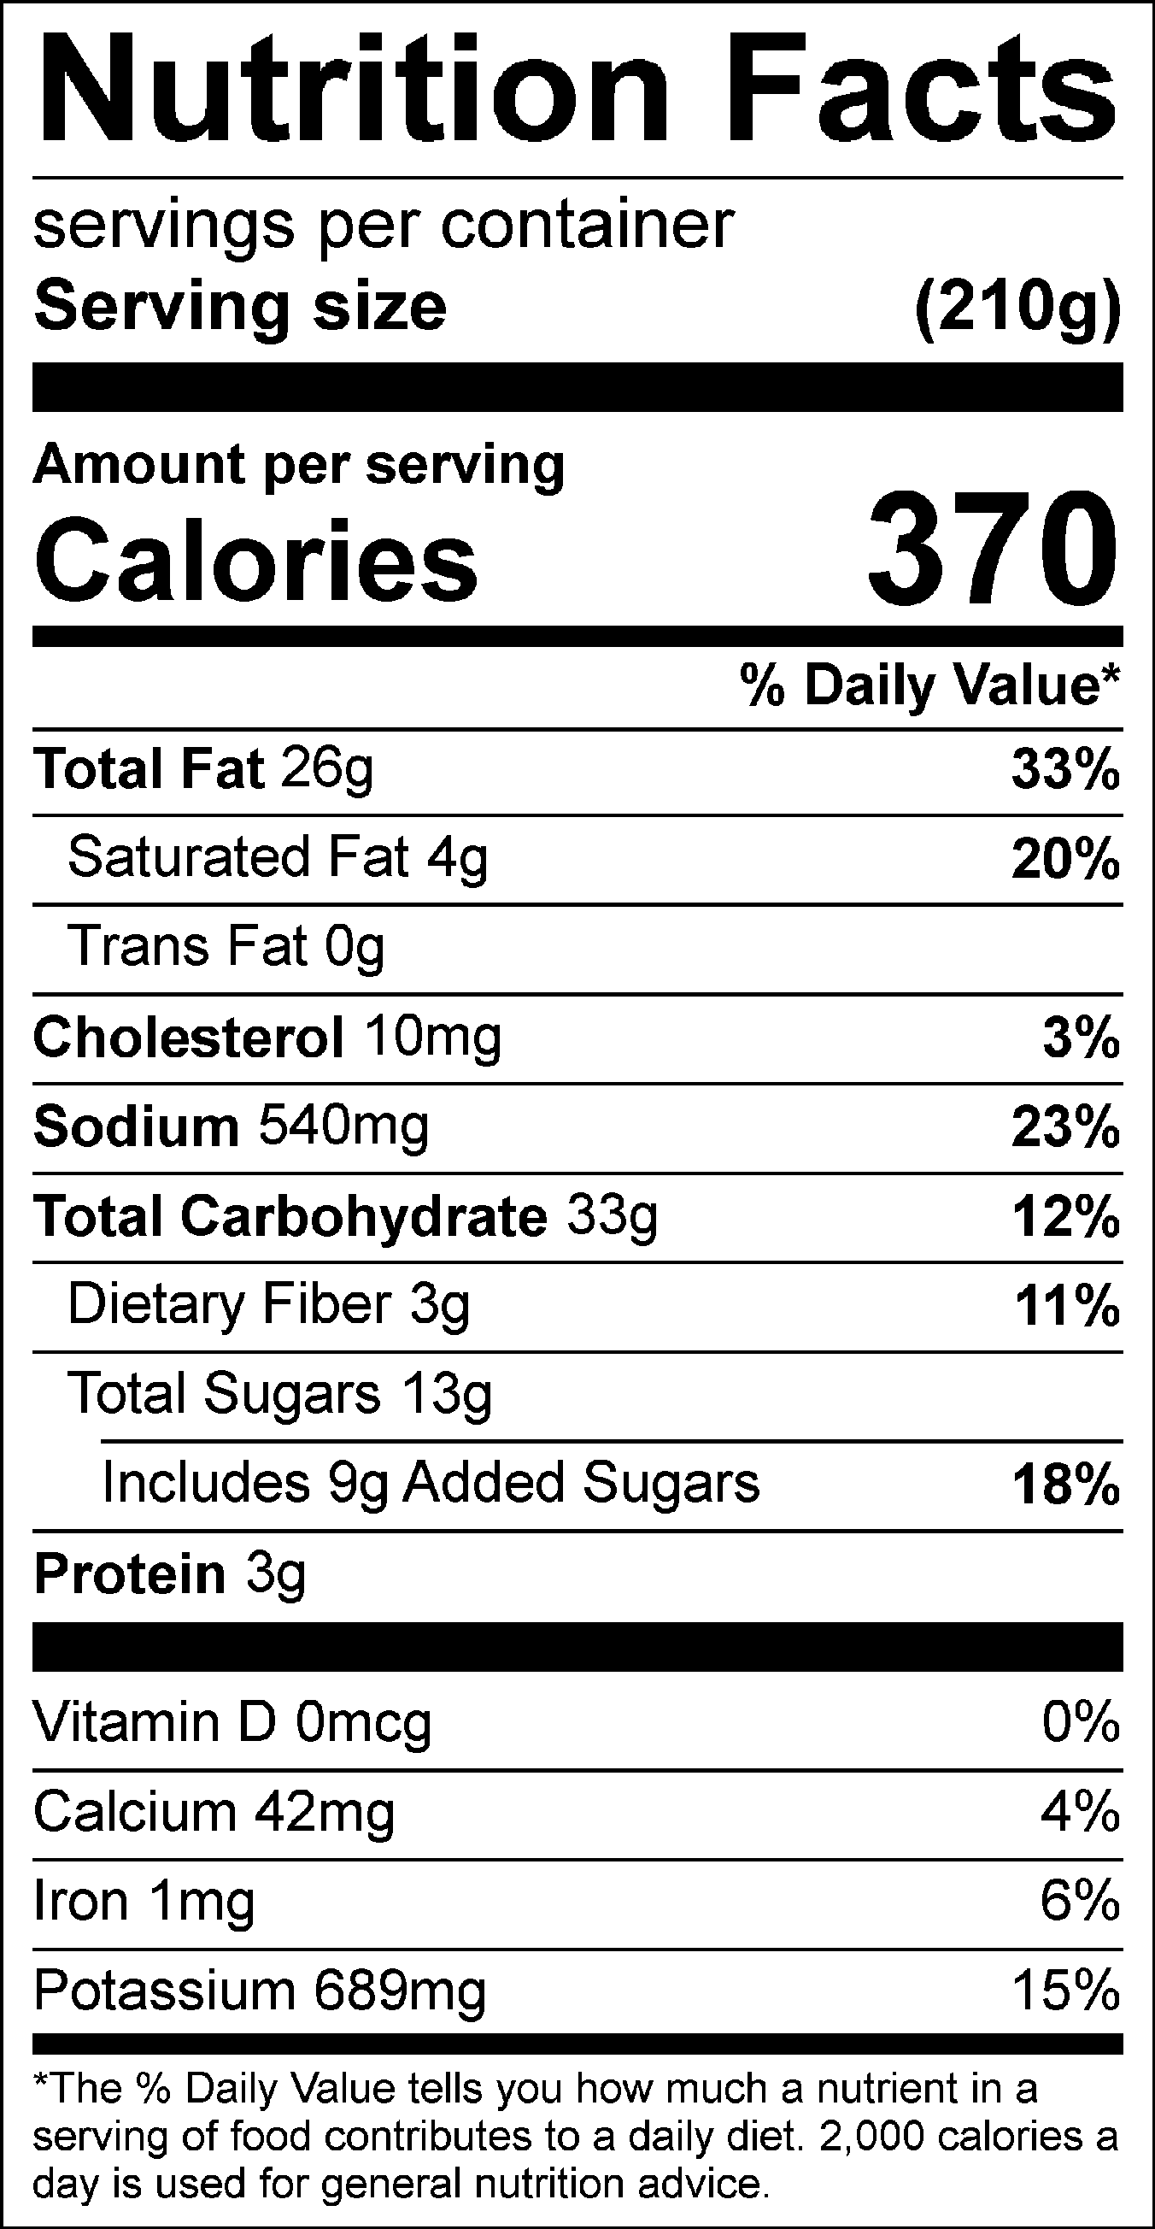

Vitamin C: 11.34mg