Potato Pizzas: American Smash Burger Pizza
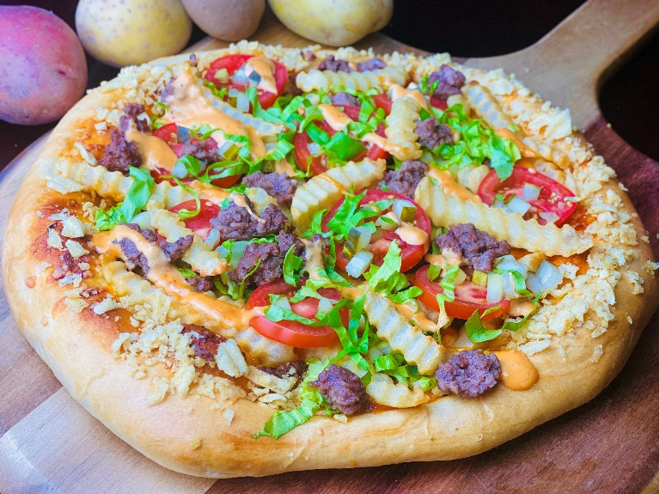
Description: Thousand Island Dressing, Cheddar Cheese, Pickles, Seasoned Ground Beef, Tomatoes, Lettuce, Crinkle Cut Fries, and a Dill Pickle Potato Chip Crumble.
Servings: 8
Preparation Time: 20 minutes
Cooking Time: 20 minutes
Total Time: 40 minutes
Potato Type: Crinkle Cut Fries, Potato Chips
Course: Main Entrée, Pizza, American

Ingredients
- 10 ounces Ground Beef
- ½ tablespoon Kosher Salt
- 2 teaspoons Freshly Ground Black Pepper
- 16-ounce Prepared Pizza Dough
- 10 fluid ounces Thousand Island Dressing
- 8 ounces Cheddar Cheese, shredded
- 1/3 cup Dill Pickles, chopped
- 8 ounces Crinkle Cut Fries, cooked
- 6 ounces Roma Tomatoes, sliced
- 1 cup Romaine Lettuce, shredded
- 2 tablespoons Unsalted Butter, melted
- 2 ounces Dill Pickle Flavored Potato Chips, crushed

Preparation
- Preheat the oven to 425 F.
- In a medium pan over medium high heat, sauté the ground beef. Season the ground beef with the salt and pepper and cook until the meat is browned and fully cooked, about 8-10 minutes. Allow the meat to cool slightly before using.
- Pull and stretch the dough so that a 16-inch round disc is formed. The dough should then be placed on a pizza peel sprinkled lightly with corn meal or flour to prevent sticking.
- Evenly spread a 10-ounce ladle of Thousand Island Dressing on the dough, this should be done by starting in the center of the disc and using the back of the ladle to evenly spread it outward. Make sure to leave about 1-inch un-sauced for the crust edge.
- Sprinkle the cheese evenly on top of the dressing. Followed by 10 ounces of the cooked and seasoned ground beef.
- Top the pizza with a 1/3 cup of chopped pickles and 8 ounces of the cooked crinkle cut fries.
- Place the pizza in the oven on a pizza stone or on the back side of a sheet pan.
- Cook the pizza for 18-20 minutes, rotating it once halfway though to ensure even cooking.
- Remove the pizza from the oven and top it with the sliced tomatoes, and shredded lettuce. Brush the crust with the melted butter. Sprinkle the crust with the crushed dill flavored potato chips. Cut the pizza into 8 slices. Enjoy!

Notes
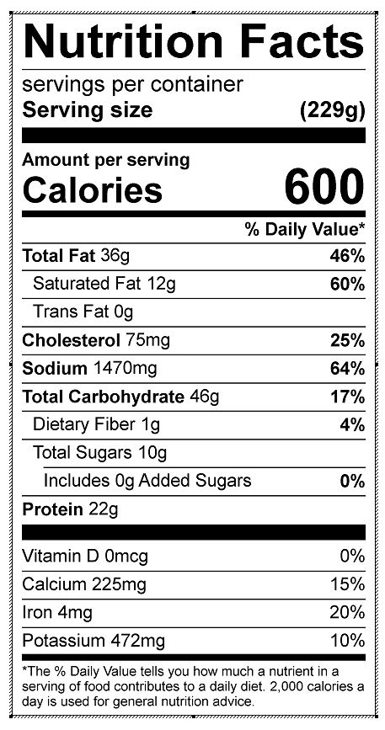
Vitamin C: 8.15 mg

