**Air Fryer Sesame Crusted Potatoes with Chili Ponzu**

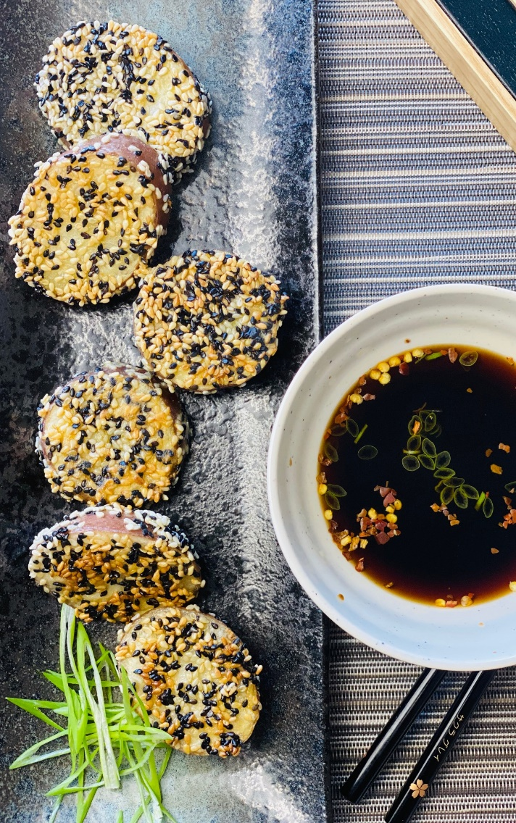

**Description:** Tender potatoes with a toasted sesame crust, served with a spicy citrus soy sauce.

**Servings:** 4

**Preparation Time:** 10 minutes

**Cooking Time:** 25 minutes

**Total Time:** 35 minutes

**Potato Type:** Reds

**Course:** Appetizer, Side, Asian

**Ingredients**

* As Needed Cooking Oil Spray
* 6 each (2 ounce) Red Potatoes, washed and dried
* 2 tablespoons Cornstarch
* ½ teaspoon Salt
* ¼ teaspoon Ground White Pepper
* 2 each Large Eggs
* ¼ cup Black Sesame Seeds
* ½ tablespoon White Sesame Seeds
* ½ cup Ponzu (Citrus Soy Sauce, regular Soy Sauce can be subbed with 2 tablespoons lemon or lime juice added)
* 1 teaspoon Crushed Red Chili Flakes
* 1/4 cup Green Onion, chopped

**Preparation**

1. Preheat the air fryer to 350 °F
2. Slice the potatoes widthwise into 1-inch slices.
3. Cook the potatoes in a pot of water for 15 minutes until they are just fork tender. Drain the potatoes and allow to cool for about 5 minutes.
4. Lightly Spray the air fryer basket with the cooking oil spray.
5. In a small bowl whisk the cornstarch, salt, pepper and eggs together to form a light batter. Mix the sesame seeds together on a plate.
6. Dip the potatoes into the batter, shaking off any excess egg. Dip the flat side of the potatoes into the mixed sesame seeds and repeat on the other side.
7. Place the potatoes in the basket of the air fryer and lightly mist the tops with cooking oil spray.
8. Cook the potatoes for 10 minutes or until they are golden brown
9. While the potatoes are cooking mix the ponzu sauce with the crushed red chili flakes and green onion. Remove the potatoes from the air fryer and serve with the chili ponzu. Enjoy!

**Notes**

* Both types of sesame seeds are not needed. White Sesame seeds are more tender than black sesame seeds and are typically easier to find. Feel free to omit the black sesame seeds.

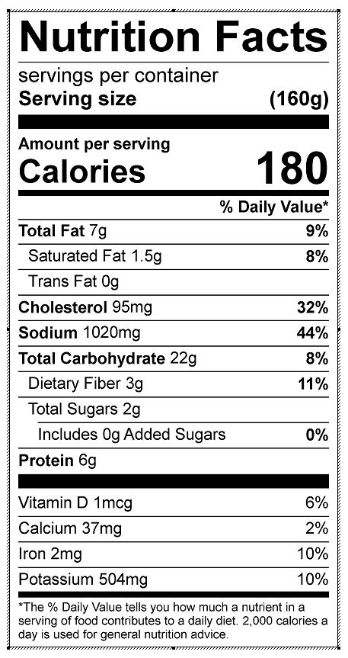

Vitamin C: 8.46 mg