**Air Fryer Parmesan Potato Pizza Crusts**

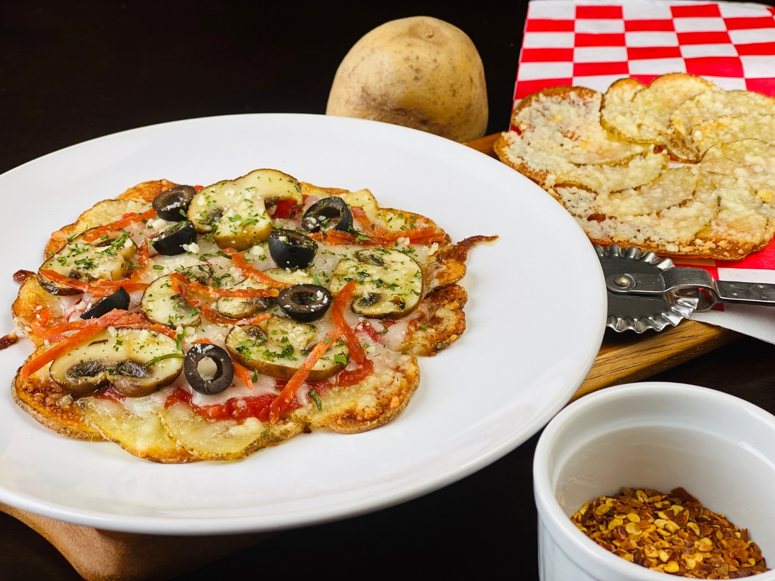

**Description:** A crispy thin wheel of potatoes perfect for gluten free personal pizzas.

**Servings:** 1

**Preparation Time:** 10

**Cooking Time:** 25 minutes

**Total Time:** 35 minutes

**Potato Type:** Yellow

**Course:** Lunch Entrée, Dinner Entrée, Shared Appetizer

**Ingredients**

* As Needed Cooking Oil Spray
* 1/2 each (4 ounce) Yellow Potato, washed and dried
* ½ tablespoon Olive Oil
* ½ teaspoon Fine Sea Salt
* ¼ teaspoon Freshly Ground Black Pepper
* 1 tablespoon Parmesan Cheese
* 3 tablespoons Marinara Sauce
* 3 tablespoons Part Skim Shredded Mozzarella
* As Needed Topping of Your Choice

**Preparation**

1. Preheat the air fryer to 375 °F
2. Thinly slice the potatoes either with a knife or a mandoline/food processor with a thin setting for slicing works well too.
3. Line the bottom of the air fryer basket with aluminum foil. Lightly spray the aluminum foil with cooking oil spray.
4. Arrange the potato slices on the aluminum foil in a circular pattern shingling them slightly (see photo). Each pizza should take about 10-12 slices of potatoes.
5. Cook the potatoes in the air fryer for 12-14 minutes. The potatoes should just begin to take on color. Remove the potatoes and sprinkle the “crust” with the parmesan cheese. Return the crust to the oven and bake for another 3-5 minutes. The crust should be golden, and the cheese melted. Remove from the oven and allow it to cool slightly. Carefully slide the crust off the aluminum foil and these can be made ahead of time.
6. Top the pizza crust with the sauce, cheese and any toppings you desired. Place the pizza in a preheated 425 °F air fryer on another piece of lightly oiled aluminum foil and cook for 3-5 minutes until the cheese is melted and slightly golden.

**Notes**

* The size of your air fryer will determine how many pizzas you can do at one time. Some air fryers have a large enough capacity to hold two potato pizza shells.

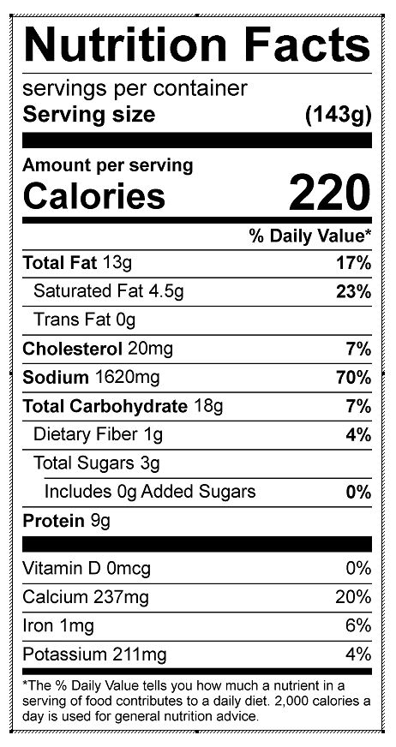

Vitamin C: 10.27 mg