**Air Fryer Outback Chips with Chipotle Sour Cream**

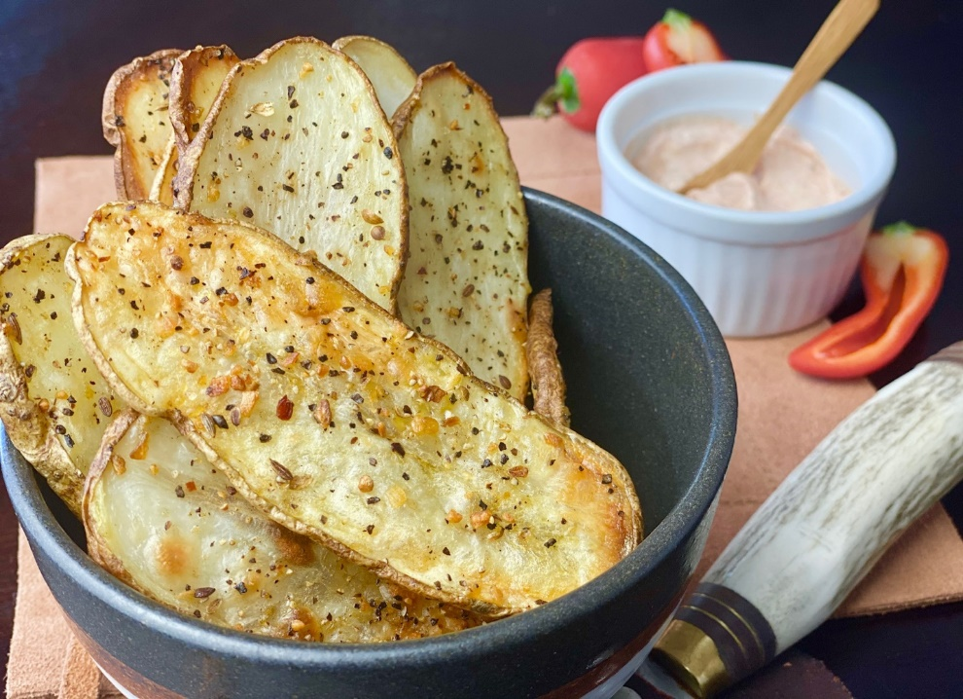

**Description:** Rustic chips seasoned with Montreal steak seasoning and served with a creamy chipotle sauce.

**Servings:** 4

**Preparation Time:** 8 minutes

**Cooking Time:** 25 minutes

**Total Time:** 33 minutes

**Potato Type:** Russet

**Course:** Side, Snack, Appetizer

**Ingredients**

* As Needed Cooking Oil Spray
* 2 each (6 ounce) Russet Potato, washed and dried
* 2 tablespoons Bacon Fat (Can be subbed with any oil)
* 1 tablespoon Montreal Steak Seasoning
* ½ cup Sour Cream
* ½ tablespoon Chipotle Peppers, canned in adobo sauce, chopped fine

**Preparation**

1. Preheat the air fryer to 400 °F
2. Slice the potatoes lengthwise into ¼ inch slices.
3. Lightly Spray the air fryer basket with the cooking oil spray.
4. Place the potatoes in the basket of the air fryer and brush them with the melted bacon fat, alternatively olive oil, vegetable oil or any plant-based oil can be subbed.
5. Sprinkle the potatoes evenly with the Montreal steak seasoning.
6. Cook the potatoes for 25 minutes or until they are golden brown and crispy.
7. While the potatoes are cooking mix the sour cream together with the chipotle peppers (less peppers can be used for a milder sauce if desired).
8. Remove the potatoes from the air fryer and serve with the chipotle sour cream. Enjoy!

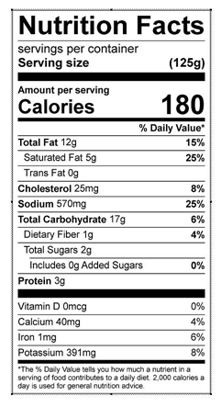

Vitamin C: 5 mg