**Air Fryer Jamaican Jerk Fries with an Easy Mango Salsa**

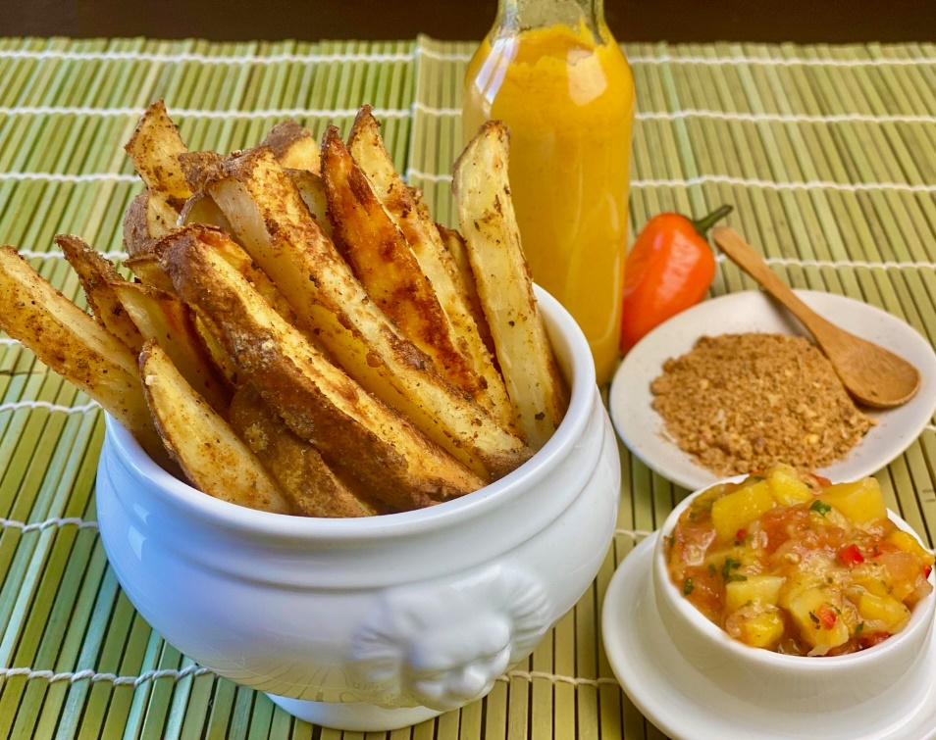

**Description:** Spicy and crispy fries cooked in air fryer with jerk seasoning, served up with a simple mango salsa.

**Servings:** 4

**Preparation Time:** 10 minutes

**Cooking Time:** 20 minutes

**Total Time:** 30 minutes

**Potato Type:** Russet

**Course:** Side, Snack, Appetizer

**Ingredients**

* As Needed Cooking Oil Spray
* 2 each (6 ounce) Russet Potato, washed and dried
* 2 tablespoons Coconut Oil, melted
* 1-1/2 tablespoons Jerk Seasoning
* 1 teaspoon Kosher Salt
* ½ cup Frozen Mango, thawed and diced ¼ inch cubes
* ½ cup Prepared Pico De Gallo (Salsa)

**Preparation**

1. Preheat the air fryer to 390 °F
2. Slice the potatoes lengthwise into ½ inch fries.
3. Lightly Spray the air fryer basket with the cooking oil spray.
4. Place the cut potatoes in a bowl and drizzle them with the coconut oil. Toss to combine and then season with the jerk seasoning.
5. Place the seasoned potatoes in the basket of the air fryer and

cook the potatoes for 20 minutes or until they are golden brown and crispy.

1. While the potatoes are cooking make the salsa by combining the diced mangos with the pre-purchased Pico de Gallo (salsa)
2. Remove the potatoes from the air fryer and serve with the mango salsa. Enjoy!

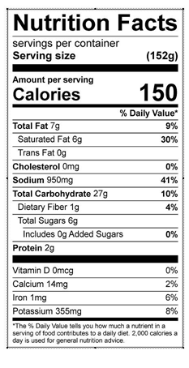

Vitamin C: 12 mg