**Air Fryer General Tso’s Potatoes**

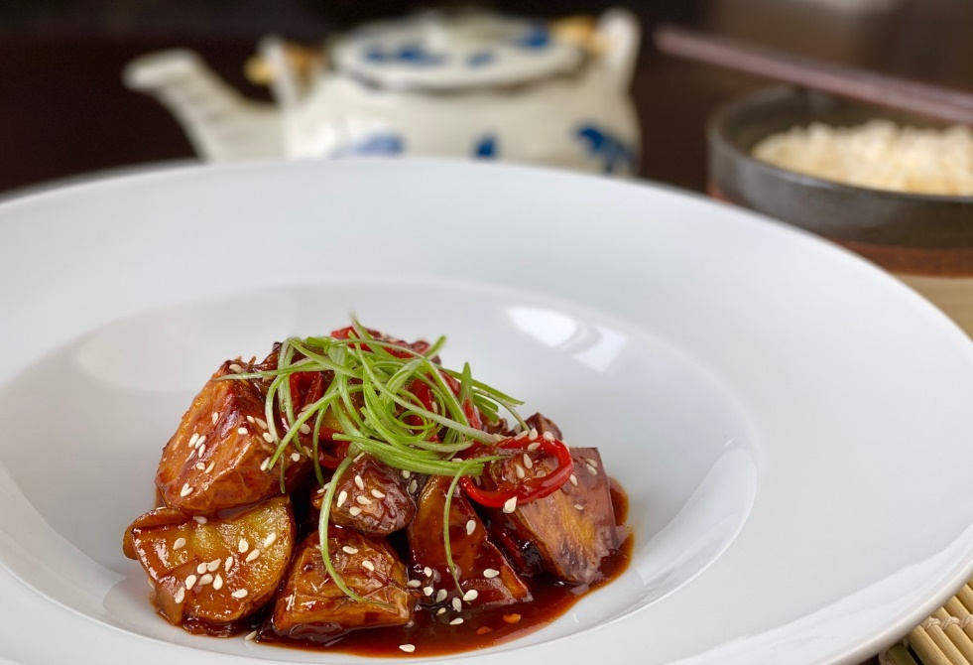

**Description:** Sticky and spicy and wedged yellow potatoes cooked in an air fryer and tossed with a fragrant chili hoisin sauce.

**Servings:** 4

**Preparation Time:** 12 minutes

**Cooking Time:** 25 minutes

**Total Time:** 37 minutes

**Potato Type:** Yellows

**Course:** Lunch Entrée, Dinner Entree, Asian

**Ingredients**

* As Needed Cooking Oil Spray
* 8 each (3 ounce) Yellow Potatoes, washed and dried
* 1 tablespoon Sesame Oil
* ½ teaspoon Fine Sea Salt
* ¼ teaspoon Freshly Ground Black Pepper
* ¼ cup Red Onion, sliced
* 2 each Garlic Cloves, Sliced
* 2 each Fresno Chili, sliced (Red Bell Pepper can be subbed)
* ½ cup Prepared General Tso’s Sauce
* ¼ cup Green Onion, sliced

**Preparation**

1. Preheat the air fryer to 400 °F
2. Slice the potatoes into wedges lengthwise, you should get 4 wedges per potato. To do this start by cutting the potato in half lengthwise, then cut each half in half, lengthwise, and lastly each quarter in half lengthwise. Place the potato wedges in a bowl and toss them with the sesame oil.
3. Lightly Spray the air fryer basket with the cooking oil spray.
4. Place the potato wedges in the basket of the air fryer and cook the potatoes for 22-25 minutes or until they are golden brown and crispy on the outside but light and fluffy on the inside.
5. While the potatoes are cooking, make the sauce. In medium sauté pan or a wok, spray some cooking spray and heat the pan over medium high heat. Add the onions and garlic and sauté for 2-3 minutes remove from the heat and add the sauce. Stir to combine.
6. Gently remove the wedges from air fryer. Place the potatoes into the sauté pan with the sauce and stir to combine. Arrange the potatoes with the sauce in a serving dish. Top the potatoes with the green onions and serve.

**Notes**

* Frozen potato wedges can also be substituted in this recipe for fresh potatoes. Cook the potatoes from frozen, reduce the cook time to 15 minutes in the air fryer if subbing frozen potato wedges or fry the potatoes to according to the instructions (nutritionals will vary with this method). Proceed with the recipe as directed after that.

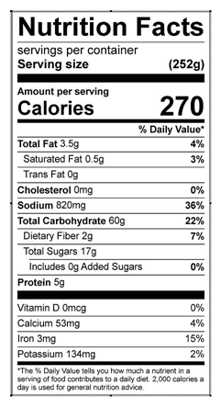

Vitamin C: 74 mg