**Air Fryer Garlic Parmesan Potatoes**



**Description:** Tender and creamy red potatoes cooked in the air fryer until crispy then tossed lightly in a garlic and parmesan butter.

**Servings:** 4

**Preparation Time:** 5 minutes

**Cooking Time:** 25 minutes

**Total Time:** 30 minutes

**Potato Type:** Reds

**Course:** Side, Snack, Appetizer

**Ingredients**

* As Needed Cooking Oil Spray
* 8 each (3 ounce) Red Potatoes, washed and dried
* 1 tablespoon Extra Virgin Olive Oil
* 2 teaspoons Kosher Salt
* ¾ teaspoon Freshly Ground Black Pepper
* 3 tablespoons Butter (Can be subbed with olive oil)
* 1 tablespoon Chopped Garlic
* ½ tablespoon Fresh Parsley (Dried Parsley can be subbed)
* 2 tablespoons Shredded Parmesan Cheese

**Preparation**

1. Preheat the air fryer to 400 °F
2. Slice the potatoes lengthwise into ½ inch half-moon slices.
3. Lightly Spray the air fryer basket with the cooking oil spray.
4. Place the potatoes in a bowl and drizzle with the olive oil. Toss to combine and season with the salt and pepper.
5. Place the potatoes in the basket of the air fryer.
6. Cook the potatoes for 25 minutes or until they are golden brown and crispy.
7. While the potatoes are cooking combine the butter and garlic in a microwave safe bowl. Microwave for 45 sec to a minute. Remove from the microwave and stir in the parsley.
8. Remove the potatoes from the air fryer and place into a serving dish, while the potatoes are still hot, drizzle them with the garlic butter and sprinkle with the parmesan cheese.
9. Enjoy!

**Notes**

* Frozen fries can also be substituted in this recipe for fresh potatoes. Cook the potatoes from frozen and reduce the cooking time to 15 minutes in the air fryer if subbing frozen potato wedges or fry the potatoes according to the instructions (nutritionals will vary with this method). Proceed with the recipe as directed after that.

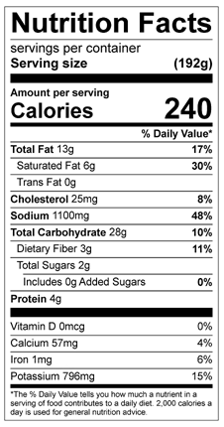

Vitamin C: 15 mg