**Air Fryer Baked Potatoes**

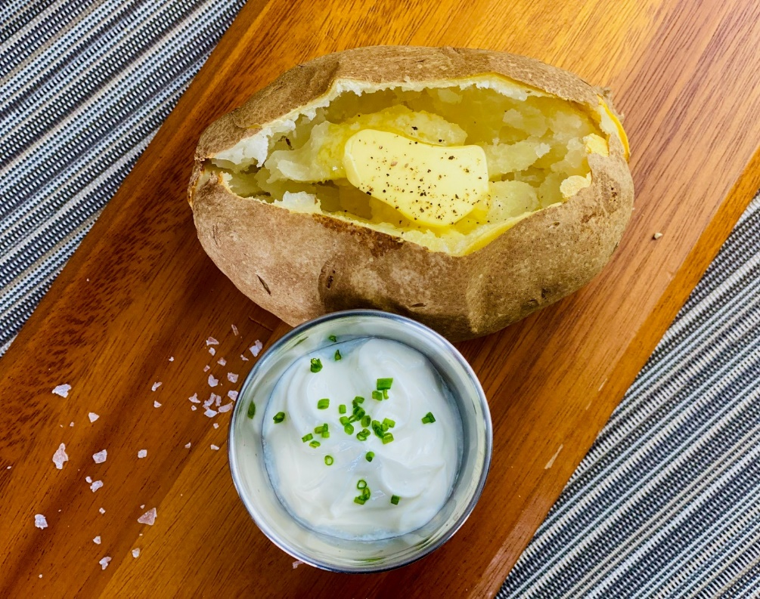

**Description:** Light and fluffy baked potatoes, a real classic.

**Servings:** 4

**Preparation Time:** 2

**Cooking Time:** 30 minutes

**Total Time:** 32 minutes

**Potato Type:** Russet

**Course:** Lunch, Dinner

**Ingredients**

* 4 each (6 ounce) Russet Potatoes, washed and dried
* 2 tablespoons Olive Oil
* 1 teaspoon Kosher Salt
* 2 tablespoons Unsalted Butter
* 4 tablespoons Non-Fat Greek Yogurt
* 2 tablespoons Fresh Chives, chopped (Green Onions can be substituted)

**Preparation**

1. Preheat the air fryer to 400 °F
2. Clean and dry the potatoes, pierce the potatoes with the tip of a knife in random places around the potato to allow steam to escape as they are cooking.
3. Place the potatoes in the air fryer basket and cook for 30-40 minutes or until the internal temperature reaches 205 F. It may take longer if the potatoes are bigger. To speed up the process the potatoes can be put in the microwave for about 10 minutes prior to placing them in the air fryer.
4. Brush the outside of the potatoes with the oil and season with the salt. Place the potatoes back in the air fryer for 1-2 minutes to get the skin nice and crispy.
5. Remove the potatoes and allow them to cool slightly before slicing open. Top each potato with ½ a tablespoon of butter.
6. Serve the potatoes with the non-fat Greek yogurt and top with chives.

**Notes**

* Additional toppings can be added if desired (Bacon, Cheddar Cheese and Green Onions are pretty classic but try roasted mushrooms, feta cheese, sundried tomatoes, black olives, artichoke hearts, smoked salmon, arugula, broccoli, spinach, pepper jack cheese, goat cheese, crème fraiche, etc.)
* Make plenty for the whole family and have them customize their own by setting out a bunch of toppings on the dinner table.

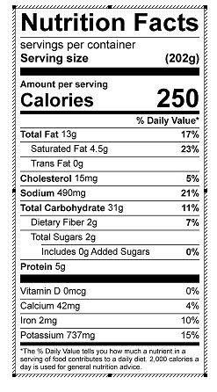

Vitamin C:10.57 mg