Quick Homemade Gnocchi Caprese Salad
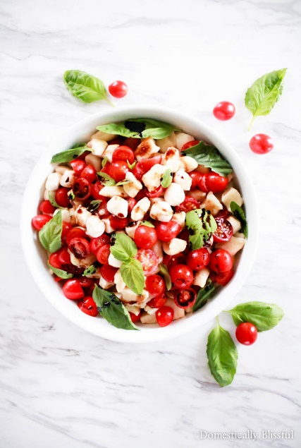

Description: Quick Homemade Gnocchi Caprese Salad is filled with fresh flavors & can be handmade in under an hour & served as a special appetizer, side, or main course dish this summer.

Recipe by: Giustina Miller

Website Link: DomesticallyBlissful.com

Prep Time: 40 minutes

Cook Time: 5 minutes

Ready Time: 45 minutes

Potato Type: Russet Potato

Serves: 4-6

Prep Method: Microwave/Boil

Course: Appetizer, side dish, main course

Ingredients
- 1 large Russet potato
- 1 medium egg
- 1/2-1 cup all-purpose flour
- 2 Tablespoons extra virgin olive oil
- Mini mozzarella (8 oz)
- Cherry tomatoes (approximately 10 oz)
- Basil
- Balsamic

Preparation

- First clean your potato & then use a knife to make several small slits (10-12) around your potato.
- Place the potato on a microwavable plate, covered by a wet (paper) towel, & microwave for 5-7 minutes, rotating the potato halfway through, until the potato is tender on the inside.
- While your potato is microwaving place a pot of salted water on the stove & bring to a boil.
- When your potato is tender, work quickly to peel & rice the potato.
- Once the potato has cooled heap the potato in a pile, add one egg, cover with 1/2 cup flour, & combine using your hands to create a dough ball. Add flour as needed until it is no longer sticky.
- Roll out the dough into a rope like shape that is approximately 1/2 inch thick. Use a knife to cut the dough into gnocchi shapes, about 1/2 inch.
- Once all of your dough is cut into gnocchi pieces boil your gnocchi until it rises to the top of the pot & then let it cook for an additional 2-3 minutes, stirring occasionally.
- Strain your gnocchi & toss it with 2 tablespoons of olive oil.
- Gently mix in all of the mini mozzarella, cherry tomatoes, & basil.
- Serve warm or chilled with a drizzle of balsamic.

Notes

- If you prefer thickened balsamic simply pour the balsamic in a pan & bring it to a simmer at medium heat, then reduce the heat to low & let it simmer for 10-15 minutes until thickened.
- This keeps the potato from drying out.
- You can test this with a knife.
- The amount of flour will vary depending on the size of your potato, the moisture from the towel, & the egg. Also, try not to overwork your dough so that your gnocchi stays light & airy.
- Total cooking time is about 5-7 minutes.

