**Potato Toast with Creamy Avocado**



**Servings**: 4

**Preparation Time**: 5 minutes

**Cooking Time:** 20 minutes

**Total Time:** 30 minutes

**Potato Type:** Russet

**Ingredients:**

* 1-pound Russet Potatoes, Sliced ½-inch thick lengthwise
* 2 tablespoons Extra Virgin Olive Oil
* As Needed Salt and Pepper
* 1 cup Prepared Guacamole
* ¼ cup Radishes, sliced
* ¼ cup Cilantro Leaves
* 2 tablespoons Everything Bagel Seasoning

**Preparation**

1. Set the oven to broil.
2. Rinse and scrub the potatoes and cut them into ½ inch planks lengthwise.
3. Place the potatoes in a pot and cover with water. Bring the potatoes to a boil over high heat. Reduce the heat to medium and allow the potatoes to cook for 12-14 minutes. Drain the potatoes, place them on a foil lined baking sheet, and brush them with olive oil. (At this stage the potatoes can be refrigerated and used throughout the week for this recipe).
4. Place the potatoes under the broiler and cook for 2-3 minutes on each side until the potatoes are golden brown. Remove the potatoes from the oven and keep warm until ready to use.
5. Top the potatoes with the guacamole, radish slices and cilantro. Sprinkle the tops of the potato toasts with everything bagel seasoning.

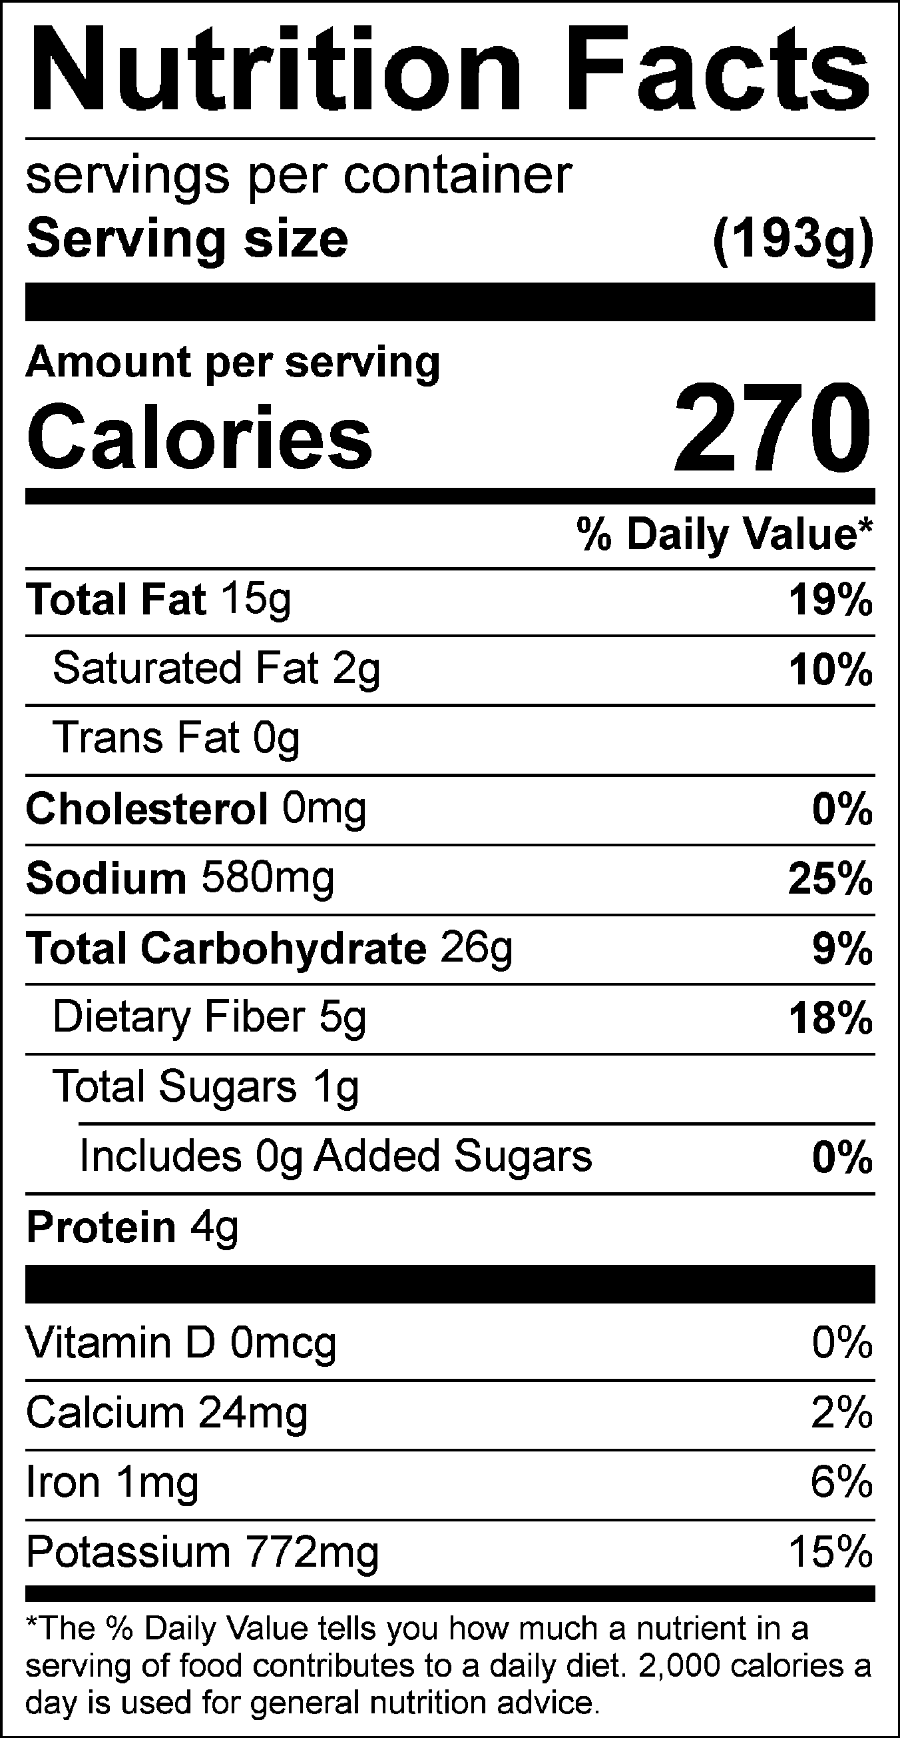

Vitamin C: 13.81 mg