Orange Chicken Pineapple Potato Kebabs
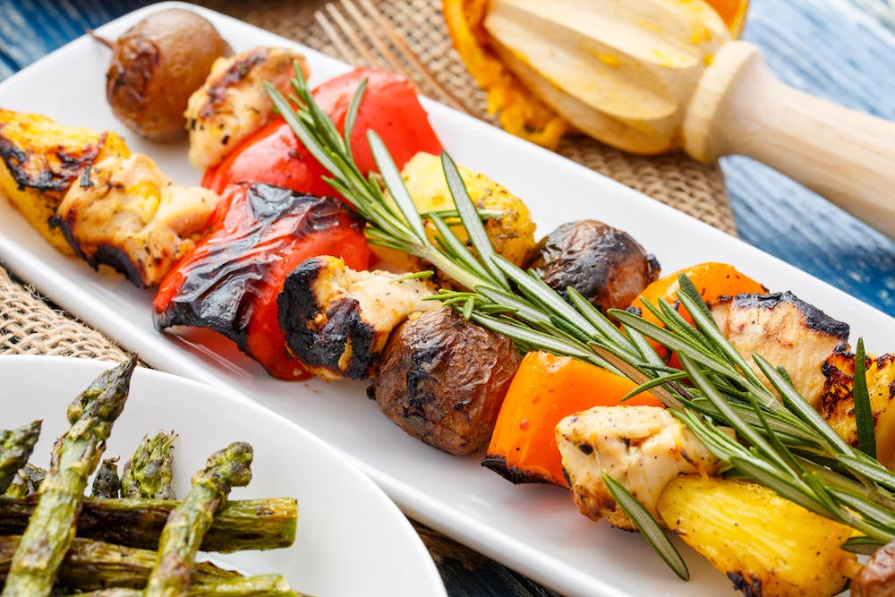
Description: Marinate these kebabs the night before you want to serve them to infuse them with the fragrant flavors of fresh herbs and spices.
Recipe by: Little Potato Company
Website Link: https://www.littlepotatoes.com/en/recipes/orange-chicken-pineapple-potato-kebabs/
Prep Time: 20 minutes
Cook Time: 15 minutes
Ready Time: 35 minutes
Potato Type: 1 lb. petite potatoes
Serves: 12
Prep Method: Microwave & Grill
Course: Main

Ingredients
Kebabs:
- 1 1/4 lbs boneless, skinless chicken breasts, cubed into 1-inch pieces
- 1 lb petite potatoes
- 1 lb fresh pineapple, cubed
- 1 lb assorted bell peppers, cut into 1-inch pieces

Chicken Marinade:
- Salt and pepper, to taste
- 2 Tbsp olive oil
- Pinch of red chili flakes
- 1 Tbsp honey
- 3 sprigs fresh rosemary
- 4 garlic cloves, minced
- 1 tsp fresh ginger, minced
- Orange slices, to taste

Pineapple, Potato, and Pepper Marinade:
- 3 sprigs fresh rosemary
- 2 Tbsp olive oil
- 1/2 jalapeño, seeded and minced
- Black pepper, to taste

Preparation
Chicken:
- Place chicken into mixing bowl or plastic bag and season with salt and pepper.
- Combine remaining chicken marinade ingredients and pour over chicken. Marinate 8 to 12 hours.

Potatoes, Pineapple, and Peppers:
- Microwave 1 lb. of any varietal of petite potatoes for eight minutes, or until fork tender.
- Place cooled potatoes, pineapple, and peppers into a mixing bowl or plastic bag.
- Combine marinade ingredients and pour over produce. Marinate 8 to 12 hours.

Assembly:
- Soak wooden skewers in water for one hour before grill time. Layer chicken, pineapple, potatoes, and peppers onto skewers in any fashion you like. Discard excess marinade.
- Heat grill over medium-high heat (400°F) and lightly oil. Place kebabs onto grill. Cook for 10 to 15 minutes, turning when necessary, or until chicken reaches 160°F and is no longer pink inside.

