**Low Country Potato and Shrimp Boil**



**Description:** Tender red potatoes cooked with shrimp, corn, and sausage in a simple one pot meal.

**Servings:** 4

**Preparation Time:** 10 minutes

**Cooking Time:** 20 minutes

**Total Time:** 30 minutes

**Potato Type:** Red

**Course:** Lunch, Dinner, Entree

**Ingredients**

* 1-pound Red Potatoes, cut in half
* 3 tablespoons Corn on the Cob, cut into ½ inch rounds
* ½ pound Cajun Andouille Sausage (Kielbasa can be subbed)
* 1 pound Raw Peel and Eat Shrimp (Medium Size)
* ¼ cup Shrimp Boil Seasoning
* ¼ cup Unsalted Butter, Melted

**Preparation**

1. Wash, scrub and cut the potatoes in half.
2. Place the potatoes into a large pot and cover them with water just until the water is about 2 inches above the potatoes. Place the pot on the stove and bring it to a boil over high heat. Reduce the heat to medium. Allow the potatoes to cook for 12-14 minutes or until they are just fork tender.
3. Add the corn, sausage, shrimp, and seasoning cook for 3-5 minutes or until the shrimp is cooked.
4. Drain the pot and serve with melted butter.

**Notes**

* Pork was used for the Cajun Andouille Sausage, but chicken or turkey sausage can be substituted.

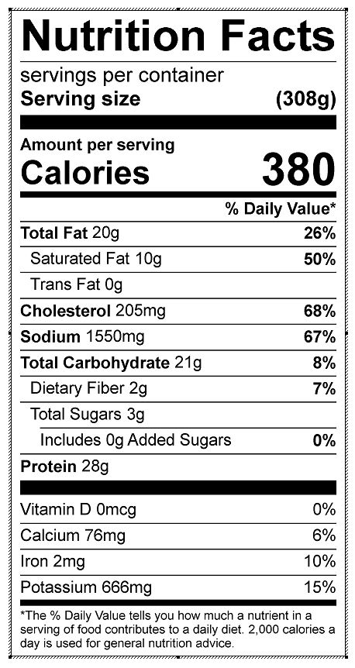

Vitamin C: 10.21 mg