Grilled Potato Bake
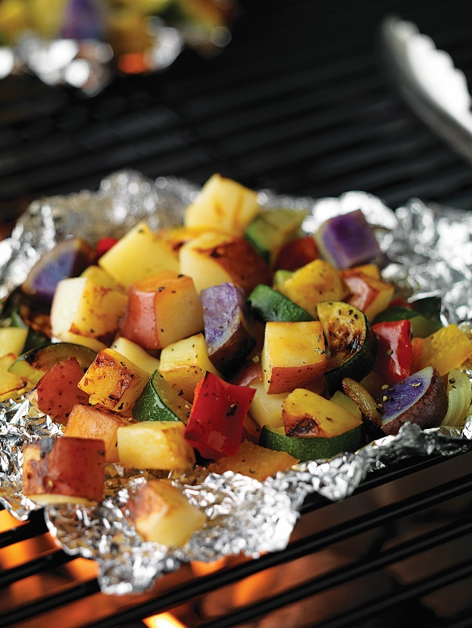
Description: Dice red, yellow, white, purple or russet potatoes with your favorite vegetables for a flavorful potato bake side dish on the grill. Add your favorite protein to make it a quick, delicious meal. Recipe as seen in popular women’s and cooking magazines!
Servings: 4
Preparation Time: 10 minutes
Cooking Time: 20 minutes
Total Time: 30 minutes
Potato Type: Red, yellow, white, purple, and russet potatoes
Course: Main Entrée

Ingredients
- 1 lbs. assorted potatoes such as red, yellow, white, purple, russet.
- 1 red bell pepper
- 1 yellow bell pepper
- 1 medium yellow onion
- 1 medium zucchini
- 1 tablespoon olive oil
- 1/4 teaspoon pepper
- 1/2 teaspoon sea salt
- Add your favorite protein
Preparation
- Preheat grill. Cut potatoes into 1/2-inch cubes and place into a microwave-safe bowl.
- Cover bowl and microwave on high for 5 minutes.
- Cut all remaining vegetables into 1-inch pieces and place all ingredients into the potato bowl.
- Toss with olive oil, salt and pepper.
- Using 12-inch long pieces of aluminum foil, place 1 1/2 cups of mixture into the center of the foil.
- Tent the foil and fold corners together rolling ends together to seal.
- Cook on grill for 15 minutes or until vegetables are tender when pierced with a sharp knife.
- Be very careful when opening the packets using tongs, as the steam will be very hot.
Instructions for cooking in a skillet
- Start by dicing your potatoes.
- Add the potatoes to a skillet with water and cover to steam.
- Dice the zucchini, onions, yellow and red peppers, and then add the veggies to the skillet.
- Add 1 Tablespoon of olive oil, and salt and pepper to taste.
- If you like, cut-up some pre-cooked chicken and add it to your skillet.
- Stirring occasionally cook for 10-15 minutes until the potatoes are tender on the fork.

Variations
- Toss vegetable mixture with taco seasoning, cheddar cheese and corn to spice up your side dish.
- Place mixture onto center of foil and cook for 15 minutes or until vegetables are tender.
- Add 1/4 cup part-skim mozzarella cheese to the vegetables mixture for a light but creamy side dish.

