**Crispy Potato Pomodoro**

**(Potatoes in Marinara Sauce)**



**Servings:** 4

**Preparation Time:** 5 minutes

**Cooking Time:** 25 minutes

**Total Time:** 25 minutes

**Potato Type:** Russet

**Ingredients:**

* 1-pound Russet Potatoes, cut lengthwise wedges
* 2 tablespoons Extra Virgin Olive Oil
* 1 tablespoon Italian Seasoning
* As Needed Salt and Pepper
* 3 cups Prepared Marinara Sauce
* ¼ cup Fresh Basil
* ¼ cup Grated Parmesan

**Directions:**

1. Preheat the oven to 425 F
2. Wash, scrub and cut the potatoes into lengthwise wedges.
3. Place the potato wedges into a large bowl. Add the olive oil, Italian seasoning, and salt/pepper. Toss to combine, and arrange the potatoes on an aluminum foil lined baking sheet.
4. Place them in the oven and cook for 25 minutes or until the potatoes are golden brown on the outside and light and fluffy on the inside.
5. While the potatoes are cooking, gently heat up the marinara sauce oven low heat.
6. To serve the potatoes, arrange the potato wedges in a bowl or serving vessel spoon some of the tomato sauce over and around the crispy potato wedges. Sprinkle the top with fresh basil and grated parmesan, serve immediately.

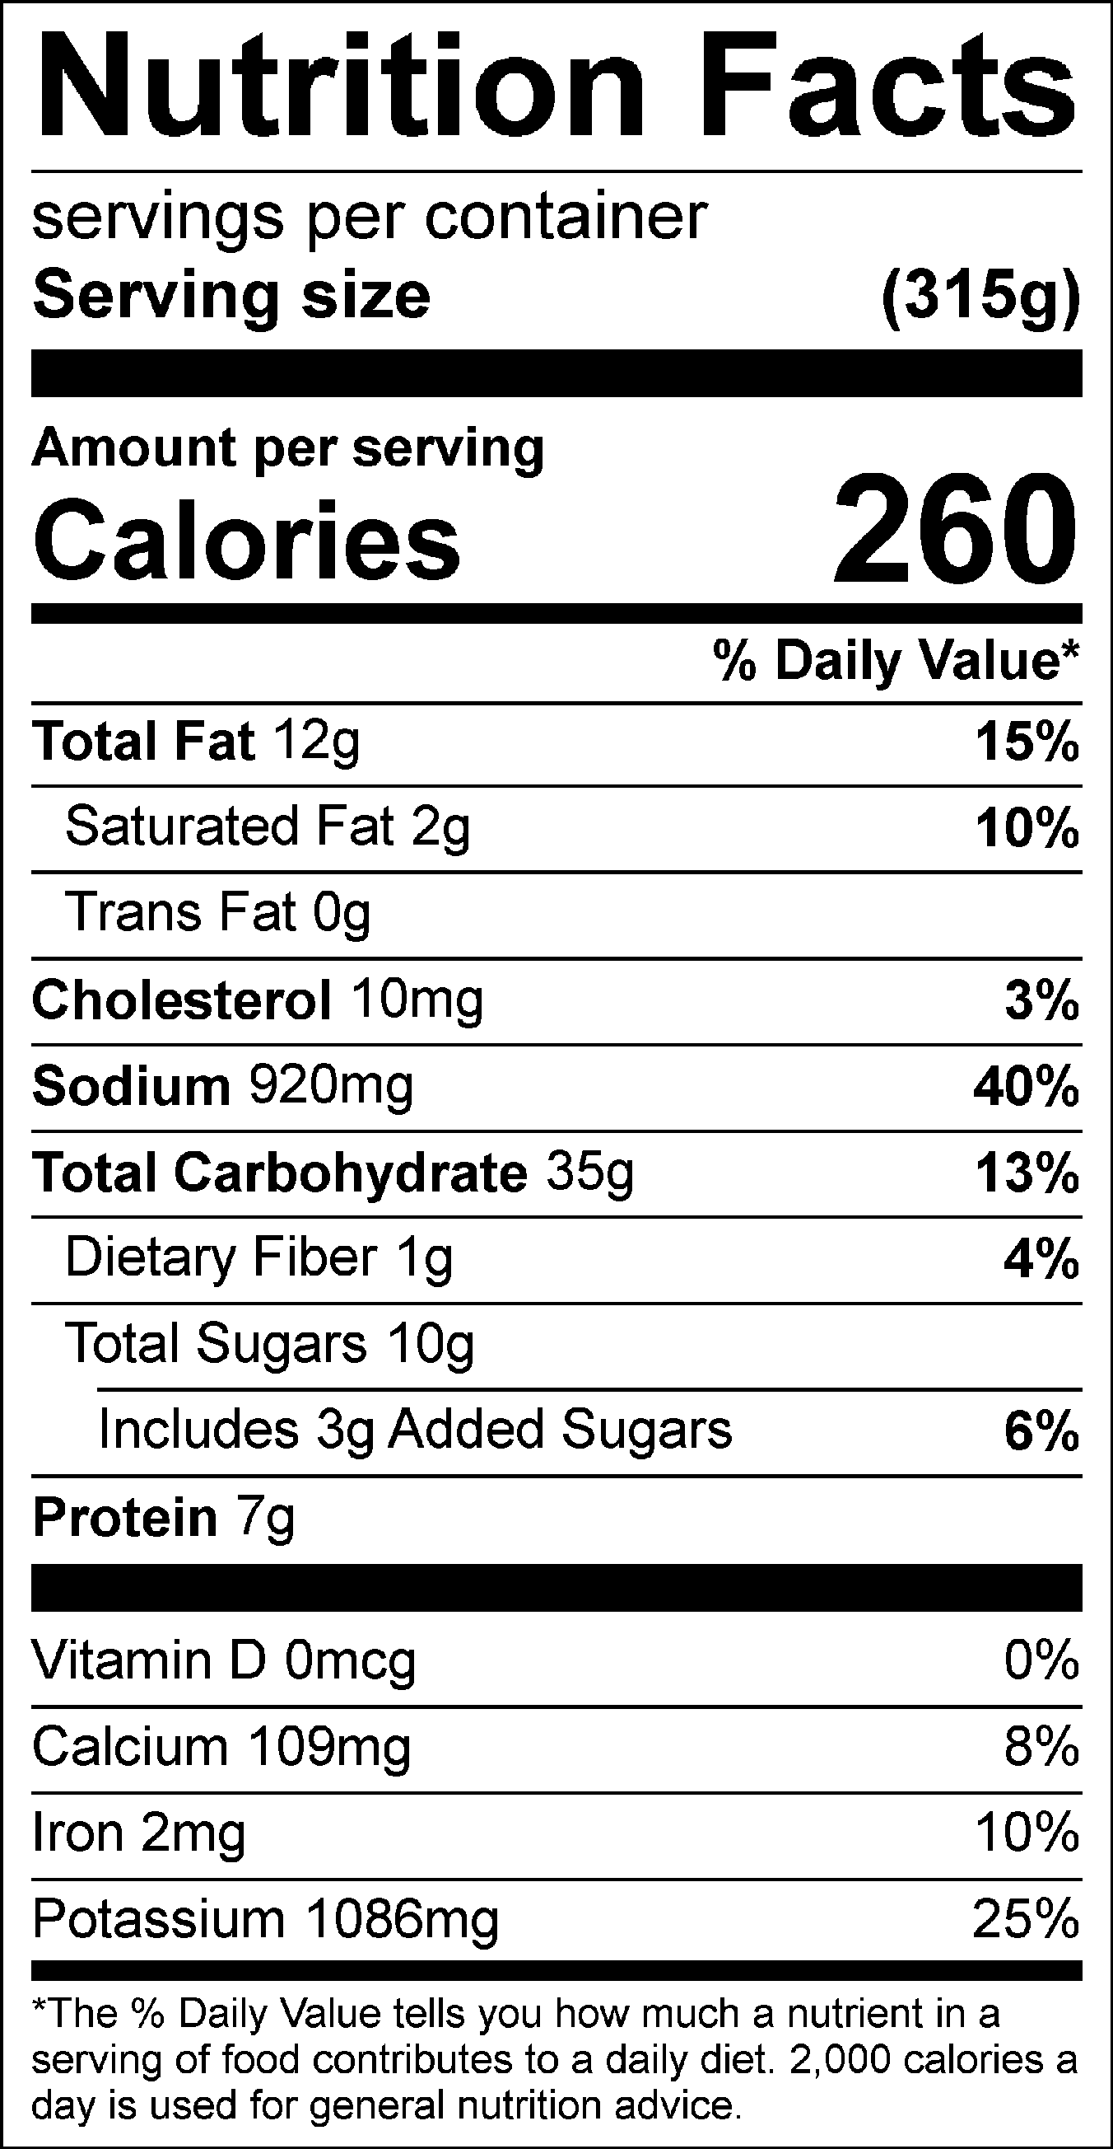

Vitamin C: 10.48 mg