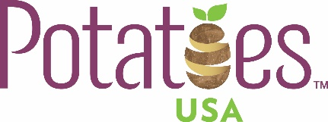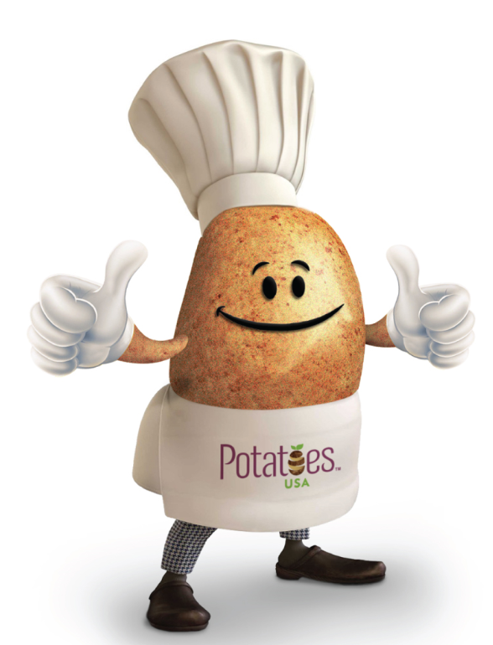

One Pan Veggie Potato Breakfast Hash
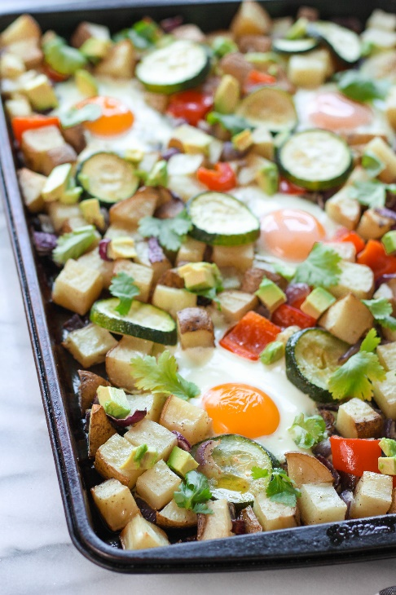
Description: This One Pan Veggie Potato Breakfast Hash is a quick and hearty way to start your day. This dish features crispy russet potatoes, and is naturally gluten free and vegetarian!
Recipe by: Liz Ingraham
Website Link: https://pumpkinandpeanutbutter.com/2018/01/15/one-pan-veggie-potato-breakfast-hash/
Prep Time: 15 minutes
Cook Time: 32-33 minutes
Ready Time: 47-48 minutes
Potato Type: Russet potatoes
Serves: 4-6
Prep Method: Baked
Course: Breakfast

Ingredients
- 3 large russet potatoes, washed and chopped into 1'' cubes
- 1 red onion, chopped into 1'' long slices
- 1 red pepper, chopped into 1'' pieces
- 1 large zucchini, sliced
- 2 Tablespoons extra virgin olive oil
- 1 teaspoon garlic powder
- 5-6 pasture raised eggs
- 1 avocado, diced
- Garnish: fresh cilantro leaves
- Salt and pepper, to taste

Preparation
- Preheat the oven to 400°F. Chop russet potatoes and vegetables (red pepper, zucchini, and red onion). Spread over a large baking sheet.
- Drizzle potatoes and vegetables with 2 Tablespoons of extra virgin olive oil and sprinkle with garlic powder, salt, and pepper. Toss to coat. Bake for 25 minutes.
- After 25 minutes, take baking sheet out of the oven. Use a spatula to make "wells" for the eggs scattered around your hash. Drizzle each "well" with a small amount of olive oil. Crack an egg into each "well".
- Place baking sheet back into the oven carefully. Bake for an additional 7-8 minutes, or until eggs have reached your preferred consistency. Remove sheet pan from oven.
- Diced up one avocado and sprinkle pieces across the vegetable potato has. Garnish with fresh cilantro leaves and any desired salt and pepper (optional). Enjoy!

