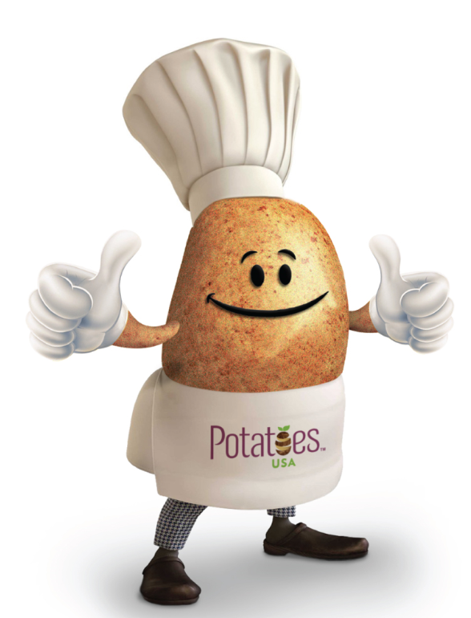

Skillet Fajita Hash browns
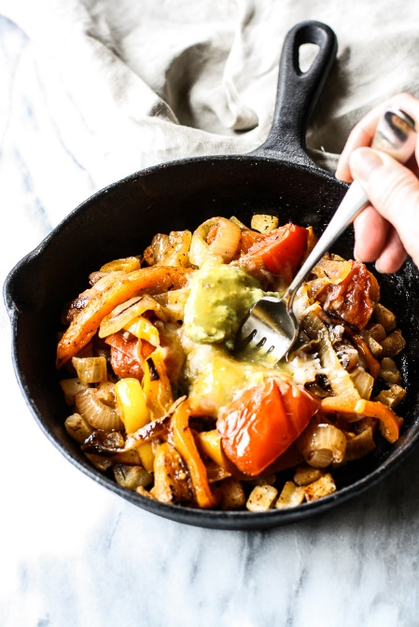
Description: With carbs for refueling and fiber to fill you up, these Skillet Fajita Hash browns are a great post-workout meal.
Recipe by: Regan Jones, RD
Website Link: http://healthyaperture.com/blog/post/skillet-fajita-hashbrowns
Prep Time: 5 minutes
Cook Time: 15 minutes
Ready Time: 20 minutes
Potato Type: Russet
Serves: 1
Prep Method: Skillet
Course: Entrée
Ingredients
- 1 teaspoon oil
- 1 1/3 cups frozen diced hash brown potatoes, thawed
- 1/4 teaspoon chili powder
- Pinch of salt
- 1/2 cup fat-free refried black beans
- 1/2 cup sauteed peppers and onions
- 1/4 cup (1 ounce) shredded Mexican cheese blend
- 1 Tablespoon guacamole
- 1 Tablespoon salsa verde

Preparation
- Preheat broiler.
- Heat oil in a small ovenproof skillet (preferably cast iron) over medium-high heat until hot; add potatoes. Sprinkle with chili powder and salt; cook 5 to 7 minutes or until crisp and golden brown.
- Top with beans, peppers, onion and cheese; broil until cheese melts. Top with guacamole and salsa verde.

Nutrition
Per serving: Calories 468, Fat: 21 g, Cholesterol: 27 mg, Sodium: 1079 mg, Carbohydrates: 54 g, Fiber: 12 g, Potassium: 1210 mg, Protein: 18 g, Vitamin C: 101%

