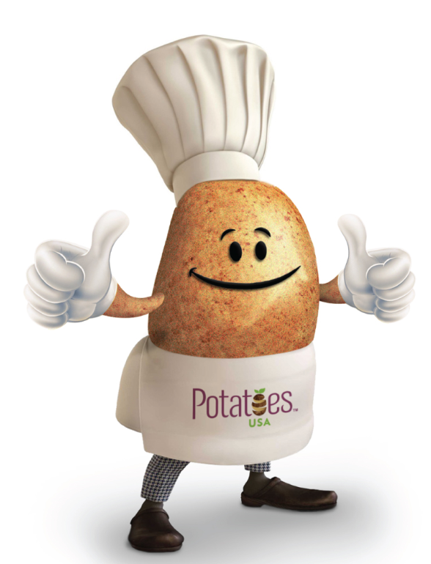

Mashed Potato Muffins
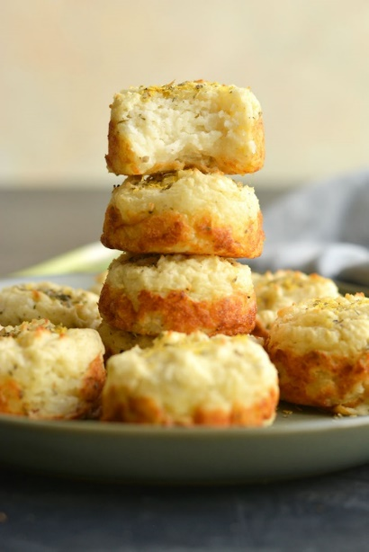
Description: Mashed Potato Muffins! A simple recipe to turn leftover mashed potatoes into a delicious side with incredible texture and flavor! Enjoy as an appetizer, dinner side, or for breakfast with eggs! Gluten Free + Low Calorie.
Recipe by: Megan Olson
Website Link: https://skinnyfitalicious.com/mashed-potato-muffins/
Prep Time: 10 minutes
Cook Time: 30 minutes
Ready Time: 40 minutes
Potato Type: White
Serves: 12
Prep Method: Baked
Course: Side

Ingredients
- 3 small white potatoes
- 1 large egg
- 1/2 cup Greek yogurt
- 1 cup unsweetened almond milk
- 1/4 cup green onions
- 1/2 Tablespoon Italian seasoning
- Salt and pepper to taste

Preparation
Mashed Potatoes
- Wash and peel the potatoes then place in a pot of boiling water. Boil until tender and soft. Pierce them with a fork to test.
- Remove from the pot, chop roughly then place in a food processor with milk, salt, Greek yogurt, green onions and Italian seasonings.
- Blend on high until smooth.

Mashed Potato Muffins
- Preheat oven to 375°F. Prepare a standard muffin tin with cooking spray. Be generous so they do not stick.
- Place mashed potatoes in a large mixing bowl with egg. Whisk together until the egg is incorporated.
- Using an ice cream scoop, scoop the mashed potatoes into the muffin tin cavities filling to the top.
- Bake at 375°F for 30 minutes until golden brown around the edges.
- Remove from the oven and let the muffins sit 5-10 minutes before removing them. Using a mini spatula to run around the edges helps to remove them.
- Enjoy immediately or keep in the refrigerator up to 7 days.

Nutrition
CALORIES 24 kcal
FAT 0.2 g
SATURATED FAT 0 g
TRANS FAT 0 g
POLYUNSATURATED FAT 0 g
MONOUNSATURATED FAT 0 g
CHOLESTEROL 0.4 mg
SODIUM 55 mg
POTASSIUM 23 mg
CARBOHYDRATES 1.3 g
FIBER 0.2 g
SUGAR 0.4 g
PROTEIN 1.2 g
VITAMIN A 0.9 %
VITAMIN C 0.5 %
CALCIUM 4.1 %
IRON 1 %

