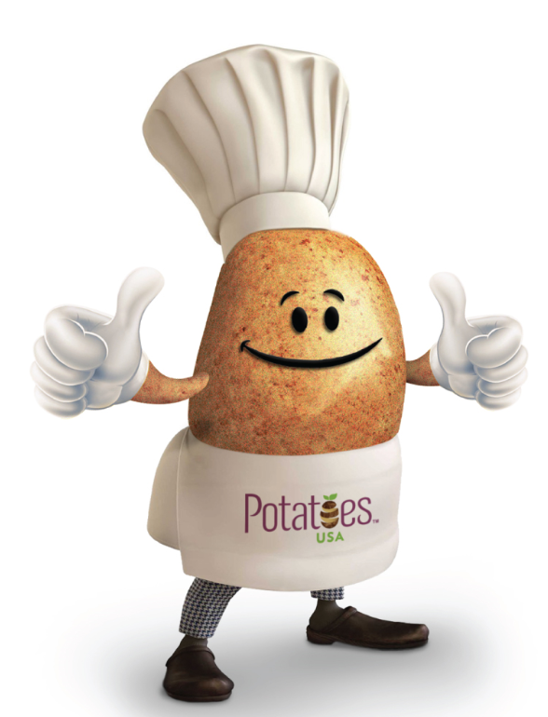

Taco Stuffed Smashed Potatoes
Description: Crispy smashed potatoes stuffed with taco filling, gooey cheese and taco toppings. The perfect customizable simple weeknight meal.
Recipe by: Julie Andrews from The Gourmet RD
Website Link: https://www.thegourmetrd.com/taco-stuffed-smashed-potatoes/
Prep Time: 10 minutes
Cook Time: 25 minutes
Ready Time: 35 minutes
Potato Type: Yellow
Serves: 4
Prep Method: Boiled/ Baked
Course: Main

Ingredients
- 1-1 ½ lbs. baby yellow or red potatoes
- 2 Tablespoons oil
- ¾ teaspoon coarse salt, divided
- ½ lb. ground beef
- ½ Tablespoon chili powder
- 2 teaspoon ground cumin
- 1 teaspoon minced onion
- 1 teaspoon minced garlic
- ¼ teaspoon ground black pepper
- 1 cup shredded Mexican cheeses
- Plain Greek yogurt or sour cream, salsa, chopped cilantro or green onion and diced avocado, for topping

Preparation
- Preheat oven to 400 °F.
- Bring a large pot of water to a boil. Add potatoes and cook about 10 minutes or until slightly soft. Drain and transfer potatoes to a greased baking sheet. Let slightly cool.
- Use the back of a spatula to gently smash each potato. Drizzle with oil and sprinkle with half of the salt. Roast 10 minutes or until crispy on the edges.
- While the potatoes roast, brown the ground beef in a skillet, breaking up into smaller pieces as it cooks. Add the remaining salt, chili powder, cumin, onion, garlic, black pepper and ¼ cup water to the beef and bring to a simmer. Spoon taco meat onto the roasted smashed potatoes. Top each with shredded cheese and bake an additional 4-5 minutes or until cheese is melted and bubbly.
- Top with desired toppings and serve.

Notes
- The potatoes can be boiled and/or roasted ahead of time to make for a quick weeknight meal.

Nutrition
Serving Size: 1/4 of recipe
- Calories: 392
- Sugar: 3
- Sodium: 520
- Fat: 14
- Saturated Fat: 4
- Unsaturated Fat: 10
- Trans Fat: 0
- Carbohydrates: 52
- Fiber: 5
- Protein: 20
- Cholesterol: 49

