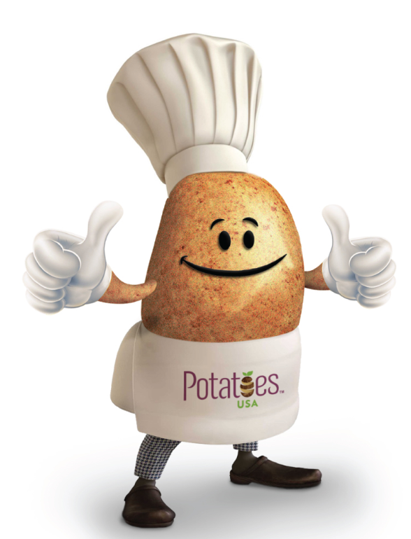

Potato Energy Bites
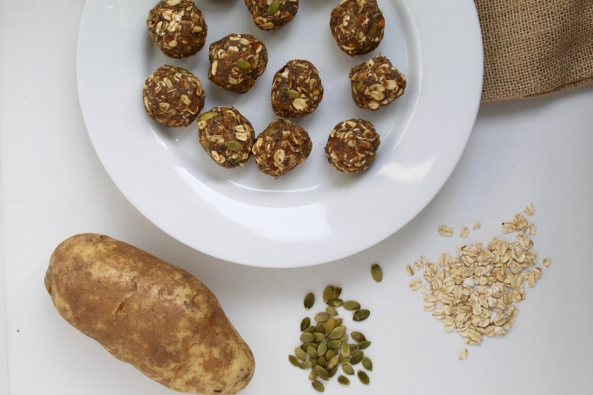
Description: A healthy and portable snack made with simple ingredients, and no refined sugars! Winner of Pre-workout recipe ReDux Challenge.
Recipe by: Emily Cooper, RDN
Website Link: http://sinfulnutrition.com/potato-energy-bites-recipe/
Prep Time: 10 min
Cook Time: 0
Ready Time: 10 min
Potato Type: Russet
Serves: 12
Prep Method: Mashed
Course: Snack

Ingredients
- 1 cup rolled oats
- 1 Tablespoon chia seeds
- 1 Tablespoon ground flax
- 1 Tablespoon unsalted pumpkin seeds
- ½ cup dried cherries
- 1 teaspoon ground cinnamon
- Flesh from ½ large russet potato, cooked (about ¾ cup)
- 3 Tablespoons natural peanut butter
- 1 teaspoon vanilla extract
- ¼ cup maple syrup

Preparation
- In a large bowl, combine oats, chia seeds, flax, pumpkin seeds, cherries, and cinnamon.
- In a separate bowl, mash together potato, peanut butter, vanilla, and maple syrup.
- Add potato mixture to oats, and stir until fully combined (I like to use my hands to mix).
- Roll into 12 balls, and store in fridge or freezer for up to 2 weeks.

Nutrition
Per ball: Calories 137, Fat: 4 g, Cholesterol: 0 mg, Sodium: 5 mg, Carbohydrates: 22 g, Fiber: 4 g, Potassium: 185 mg, Protein: 4 g, Vitamin C: 2%

