Potato Poppers with Turmeric
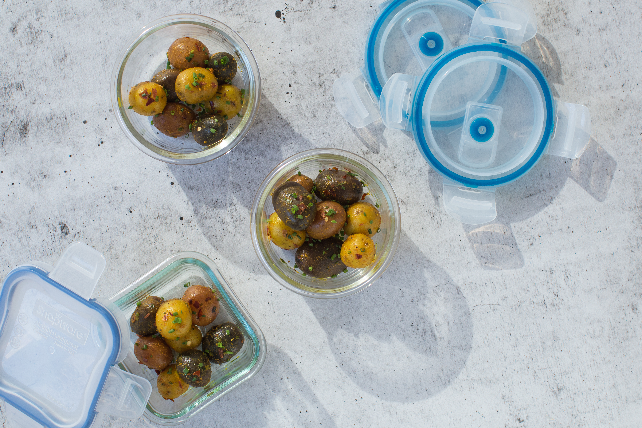
PERFORMANCE RECIPE CATEGORY: Exercise Snack
Description: This portable powerhouse snack is simple to prepare and packs a punch with bright flavors, herbs and spices. There are unlimited variations to keep you fueled throughout your workout day after day.
Recipe by: Chef Glenn Lyman, GCooks.com
Website Link: N/A
Prep Time: 5 minutes
Cook Time: 15 minutes
Ready Time: 20 minutes
Potato Type: Petite
Serves: 5 (about 8 petite potatoes per serving)
Prep Method: Steamed
Course: Appetizer, Side Dish, Snack

Ingredients:
- 1 ½ lbs. petite potatoes (any color)
- 2 Tablespoons extra virgin olive oil
- 1 Tablespoon fresh lemon juice
- 1 teaspoon ground turmeric
- 1 pinch crushed red pepper
- 1 pinch cayenne pepper
- Sea salt and pepper to taste
- 2 Tablespoons fresh chives, chopped

Preparation:
- Steam potatoes (with skin on) in a large, covered saucepan with 1 inch of lightly salted water for about 12 minutes, or until tender, drain.
- Toss immediately with olive oil, lemon, turmeric, peppers and salt. Allow to cool slightly and toss with chopped fresh chives.
- Divide into equal portions and store in re-sealable plastic bags in the refrigerator for easy access during the week.

Notes:
Time-Saving Tips:
- This recipe can be prepared in advance and stored in the refrigerator for up to 4 days. Serve at room temperature within 2 hours of refrigeration.

Customizations:
- Try substituting in fresh herbs like parsley, mint, cilantro, basil, or tarragon.
- Mix and match the spices to your preferences. Try curry powder or chili powder with ground cumin and granulated garlic. The possibilities are endless!

Nutrition
Per serving (8 petite potatoes): Calories: 154, Fat: 6 g, Cholesterol: 0 mg, Sodium: 28 mg, Carbohydrates: 25 g, Fiber: 3 g, Potassium: 584 mg, Protein: 3 g, Vitamin C: 28 mg

