Lightened Up Potato Latkes
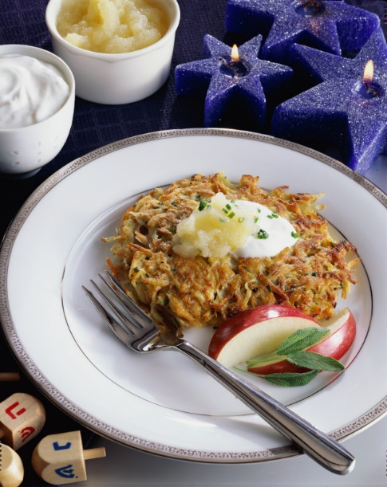
Description: Try the lightened up version of the potato latkes; you won't even know there are calories missing!
Recipe by: Potatoes USA
Website Link: https://www.potatogoodness.com/recipes/lightened-potato-latkes/
Prep Time: 15 min
Cook Time: 15min
Ready Time: 30 min
Potato Type: Russet potatoes
Serves: 4
Prep Method: Pan Fried
Course: Breakfast

Ingredients
- 2 1/2 cups shredded, unpeeled russet potatoes (about 1 lb)
- 1/2 cup grated onion
- 1/3 cup peeled, shredded carrot
- 1/3 cup flour
- 2 tablespoons snipped fresh chives
- 1 teaspoon kosher salt
- 1 egg + 1 egg white
- 2 tablespoons vegetable oil, divided
Preparation
- Scrub potatoes and coarsely grate. Immediately place in a bowl of ice water to keep potatoes from discoloring; let stand for 5 minutes.
- Meanwhile, place the onion, carrot, flour, chives, salt, pepper and eggs in a medium bowl and stir well.
- Drain the potatoes and squeeze out moisture; stir into egg mixture. Heat 1 tablespoon oil in a large non stick skillet over medium-high heat until very hot. Spoon about 1/4 cup of potato mixture for each pancake into skillet, cooking 4 at a time. Cook for 3 to 4 minutes per side, flattening with the back of a spatula and cooking until golden brown and crisp on both sides. Drain on paper towels.
- Repeat with remaining oil and potatoes.
- Serve immediately with chunky applesauce and low-fat sour cream.

Nutritionals
Calories - 216
Fat - 8g
Fiber - 3g
Protein - 6g
Potassium - 425mg

