Cold Brew Coffee Shake
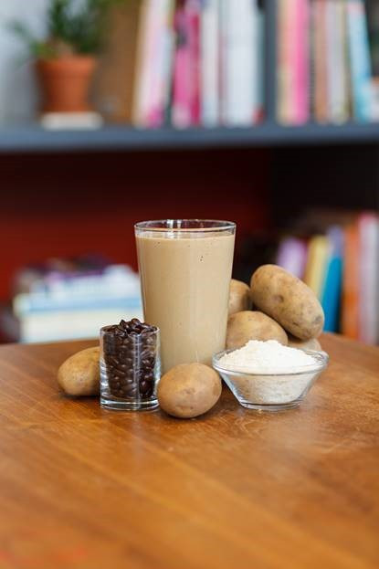
Description: Get a jolt of energy to start your day off right with this cool and creamy java smoothie. The indulgent and rich texture comes from the potatoes and will have you feeling great all morning long.
Recipe by: Potatoes USA
Website Link: https://www.potatogoodness.com/recipes/cold-brew-smoothie/
Ready Time: 5 min
Potato Type: Dehydrated potato flakes
Makes: 5 smoothies (12 oz each)

Ingredients
- 3 cups Cold Brew Coffee Concentrate
- 1 cup Whole Milk
- 2 Tablespoons Instant Espresso Powder (more or less to taste, depending on preference)
- 2 cups Standard US Potato Flakes
- 1 cup Sweetened Condensed Milk
- ¼ cup Simple Syrup
- 2 teaspoons Vanilla Extract
- 3 cups Ice

Preparation
- In a large Vitamix blender combine cold brew coffee, milk, espresso powder, and potato flakes until well combined and flakes have thickened the mixture.
- Add condensed milk, simple syrup, vanilla extract and ice and blend until smooth.
- Serve immediately.

Nutritionals
Calories - 414
Fat - 1.5g
Sodium - 529mg
Cholesterol - 31
Vitamin C - 22mg
Carbohydrates - 90g
Fiber - 6g
Protein - 14g
Potassium - 1417mg

