CARROT “CAKE” POTATO PERFORMANCE MUFFINS
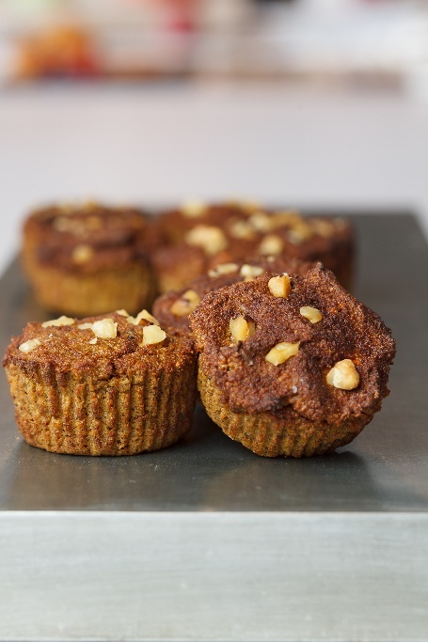

Description: A delicious spiced muffin using baked potato, cooked carrots, spices and nuts for a performance-oriented twist on classic carrot cake flavors.
Recipe by: Potatoes USA
Website Link: https://www.potatogoodness.com/recipes/carrot-cake-potato-performance-muffins/
Prep Time: 10 mins
Cook Time: 25 min
Ready Time: 35min
Potato Type: Russet potatoes
Serves: 9 muffins
Prep Method: Baked
Course: Appetizer, snack

Ingredients
- 1 cup baked potato, cooled (russet potato with skin)
- 1/2 cup sliced cooked carrots (about 2 medium carrots)
- 1 banana, peeled
- 3 eggs
- ¼ cup coconut flour
- ¼ cup coconut sugar
- 2 Tablespoons coconut oil, melted
- 1 teaspoon baking powder
- ½ teaspoon baking soda
- 1 teaspoon vanilla extract
- 1 teaspoon cinnamon
- ½ teaspoon nutmeg
- ¼ teaspoon cloves
- Pinch of sea salt
- Optional: ½ cup chopped walnuts or pecans
- Optional: ½ cup golden raisins
Preparation
- Preheat oven to 350°F.
- Put potato, carrots, banana and eggs into a blender or food processor. Blend until smooth.
- Pour into a bowl, and mix in remaining ingredients until just combined.
- Fold in nuts and raisins, if desired.
- Line a 12-cup muffin tin with paper liners and evenly pour batter into 9 of the cups.
- Bake for 20-25 minutes, or until a toothpick inserted into the center of a muffin comes out clean.
- Let the muffins cool completely before eating. Extra muffins can be stored in fridge for up to 5 days or in freezer for up to 3 months. Thaw frozen muffins in fridge for a few hours before eating.
Nutritionals

Calories
125
Fat
5g
Vitamin C
5.2mg
Carbohydrates
17g
Fiber
2.4g
Protein
3g
Potassium
236mg

