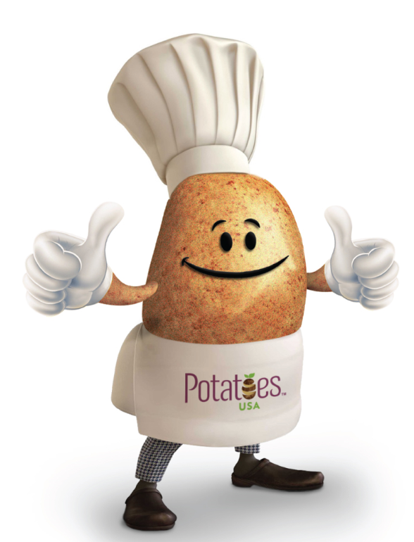
Buffalo Potato Salad
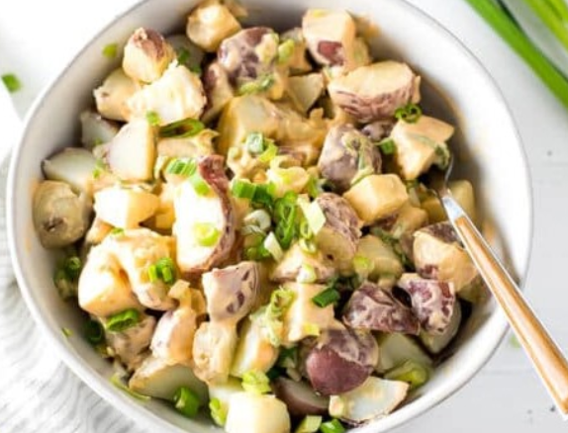
Description: Boiled small red potatoes with a creamy buffalo dressing, made with hot buffalo sauce, mayo and yogurt. Topped with chopped scallions. Great for a party, game day or celebration.
Recipe by: Cooking lsl
Website Link: https://cookinglsl.com/buffalo-potato-salad-recipe/
Prep Time: 5 mins
Cook Time: 25 mins
Ready Time: 30 mins
Potato Type: Red potatoes
Serves: 4
Prep Method: Boiled
Course: Side dish

Ingredients
- 1 1/2 lbs. small red potatoes
- 1/4 cup light mayonnaise
- 2 Tablespoon Greek yogurt
- 2-3 Tablespoon hot sauce like Frank's Red Hot
- 1/4 teaspoon garlic powder
- 1 teaspoon apple cider vinegar
- 1/2 teaspoon salt or more to taste
- 1/8 teaspoon black pepper
- 4 scallions
Preparation
- Wash potatoes and add to a large pot. Fill with water. Bring to a boil. Boil for 20 minutes, until the potatoes are fully cooked.
- Drain the water, rinse and drain again. Cut potatoes into small pieces. Add to a bowl.
- In a small bowl mix together the mayonnaise, yogurt, hot sauce, garlic powder, apple cider vinegar, salt and pepper.
- Pour dressing over the potatoes, while they are still warm. Stir and top with scallions. Add more salt if needed.

Nutritionals

Calories - 162
Fat - 3g
Sodium - 602mg
Cholesterol - 2
Vitamin C - 2.4%
Carbohydrates - 29g
Fiber - 3g
Protein - 4g
Potassium - 826mg
Sugar - 3g

