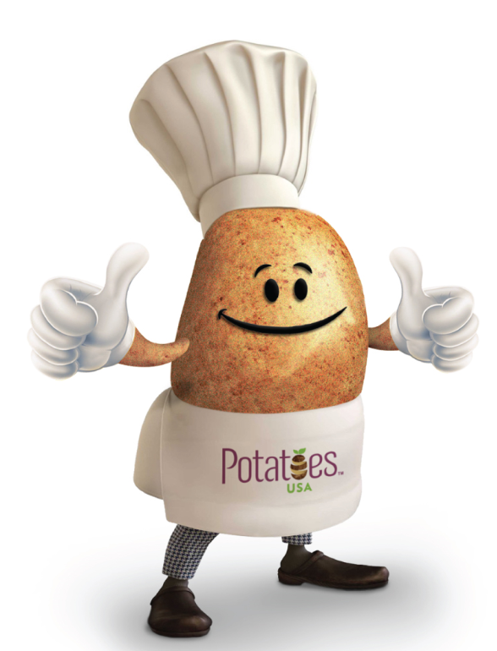

Performance Stuffed Potato Bowl- Dairy Free, High Fiber, Vegetarian

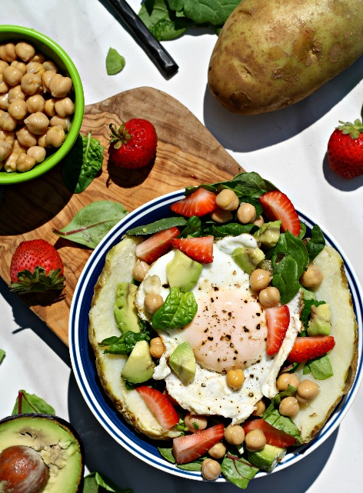
Description: A performance stuffed potato bowl is the perfect way to fuel up pre or post workout. Fill a meal prepped baked potato with fresh fresh kale, strawberries, chickpeas and an egg for a quick 5 minute meal. Packed with energy, vitamins, and carbs.
Recipe by: Looneyforfood (Patrick Looney)
Website Link: http://www.looneyforfood.com/performance-stuffed-potatoes/
Prep Time: 5 minutes
Cook Time: 1 minute
Ready Time: 6 minutes
Potato Type: Russet
Serves: 1
Prep Method: Microwave
Course: Main
Ingredients
- 173 grams (1 medium) russet potato, baked
- 21 grams (1 cup) Kale and Spinach blend, chopped
- 67 grams (1/3 cup) chickpeas, rinsed and drained
- 13 grams (2 Tablespoons) avocado, chopped
- 147 grams (1 cup) strawberries, chopped
- 1 egg cooked however you like

Preparation
- Reheat baked potato for 30 seconds in the microwave.
- Remove and slice vertically in half, then horizontally in half again.
- Press the back of fork directly down into potato to "smash" it!
- Season potato with salt and pepper if desired. Top with Kale and spinach blend.
- Top with remaining ingredients and enjoy.

Notes
additional nutrition: Potassium: 1,055 milligrams Vitamin C: 204 milligrams
Make this your own: Top it a million different ways by changing the protein, beans, fruit or veggies, etc.

Nutrition Information
Serving size: 1 potato
Calories: 375 Fat: 7 Saturated fat: 2 Unsaturated fat: 4Carbohydrates: 62 Sugar: 7 Sodium: 280 Fiber: 10 Protein: 15 Cholesterol: 186

