Potato Falafel Bowl

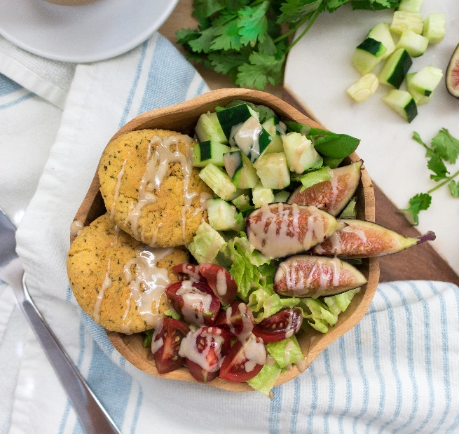

Description: Pumpkin or plain, these herb and spice filled, pillowy potato falafel are the perfect addition to your weekly performance meal prepping plan.
Recipe by: Danielle Judson Nutrition
Website Link: https://www.daniellejudson.com/potato-falafel-bowl/
Prep Time: 30 minutes
Cook Time: 20 minutes
Ready Time: 50 minutes
Potato Type: Russet
Serves: 12
Prep Method: Bake
Course: Main

Ingredients
Potato Falafel
- 2 Russet potatoes, washed, peeled and boiled
- 1 can no-salt added chickpeas, drained and rinsed
- 1/4 cup almond flour
- 1/4 cup canned pumpkin (omit for plain potato falafel)
- 1/2 cup fresh cilantro
- 1 Tablespoon lemon juice
- 2 teaspoons cumin
- 2 teaspoons coriander
- 2 teaspoons smoked paprika
- 2 teaspoons sea salt
- 1 teaspoon black pepper
Potato Falafel Bowl Toppings
- Lettuce (I used romaine & mixed greens
- Cucumber
- Figs
- Tomatoes
- Tahini for drizzling

Preparation
Potato Falafel
- Preheat oven to 375°F and line a baking sheet with parchment paper.
- Combine all falafel ingredients into a food processor, and process until a thick dough is formed. adjust spices to your taste as needed.
- Using a table spoon, roll balls of dough and place them on the parchment paper, pushing down with your fingers to flatten out.
- Bake for 15-20 minutes, until the tops begin to brown.
Potato Falafel Bowl
- Add lettuce into a bowl along with potato falafel and desired topping. Drizzle with fresh tahini and enjoy!

Nutritionals
For falafel only: Per serving (3 potato falafel):
Calories 266, Fat: 6 g, Cholesterol: 0 mg, Sodium: 220 mg, Carbohydrates: 50g, Fiber: 9 g, Potassium: 735 mg, Protein: 12g, Vitamin C: 20 mg

